Organizing Visions and the Dialectic of Novelty and Control: A Computationally Intensive Study of Executive-facing AI Discourse

Abstract
The academic discourse on digital innovation highlights a persistent tension between radical, discontinuous paradigm shifts and the continuous, mundane routines required for implementation. To bridge this divide, managerial fields rely on the collective negotiation of an organizing vision. While existing literature identifies the core functions of these visions (interpretation, legitimation, and mobilization), their dynamic interaction remains unexplored. Consequently, theory historically assumes that legitimation acts as a filtering mechanism that dampens enthusiasm until risks are mitigated. We resolve this theoretical paradox through a Computationally Intensive Theory Construction (CITC) approach, leveraging artificial intelligence (AI) as an extreme case of prolonged technological ambiguity. Operationalizing the vision's functions into three interacting discursive archetypes (the Pioneer for speculative novelty, the Guardian for legitimating control, and the Builder for normative action), we analyze 7,127 future-oriented paragraphs from executive-facing publications (Harvard Business Review and MIT Sloan Management Review, 2014–2025) using large language models and vector autoregression (VAR). Our findings reveal an endogenous ecology of attention sustained by a continuous dialectic of novelty and control in the discourse. We identify that institutional friction does not stall a technological vision but paradoxically catalyzes talk directing its mobilization. The Builder discourse surges specifically when novelty and control clash, serving as a discursive bridge that translates macro-level institutional constraints into rhetoric prescribing micro-level organizational routines. By transforming static definitions into auditable, interacting constructs, this study provides a structural explanation for how managerial fields metabolize radical technological ambiguity into continuous action.

Introduction
The emergence and diffusion of new information technologies are driven as much by discursive negotiation as by technical invention {Barrett et al., 2013, #121649}. However, the academic discourse on digital innovation is characterized by a persistent tension between two extremes: the speculative imaginary of radical, discontinuous paradigm shifts, and the pragmatic reality of continuous, mundane organizational routines. To successfully diffuse, an emerging technology must bridge this divide; radical visions must somehow be metabolized into executable action. The theory of Organizing Visions (OV) provides a foundational framework for this process, positing that a community must collaboratively construct a shared vision of a technology's purpose {Swanson and Ramiller, 1997, #75628}. An organizing vision must perform three critical functions: interpretation (sense-making), legitimation (justifying adoption), and mobilization (coordinating action) {Swanson and Ramiller, 1997, #75628}.
However, while these functions are necessary, executing them simultaneously creates an inherent discursive tension. Interpretation often presents a vast, ambiguous horizon of potential applications to generate excitement. Yet, this very ambiguity inevitably invites institutional scrutiny regarding risks and potential negative impacts that can occur if the technology is implemented carelessly. This scrutiny—a core manifestation of the legitimation function—seeks to bound the technology within acceptable norms. Historically, literature has treated legitimation (including the introduction of ethical concerns and compliance risks) as a filtering mechanism that dampens enthusiasm until risks are mitigated {Suchman, 1995, #172158; Ramiller and Swanson, 2003, #64221}. Yet, this assumption creates a theoretical paradox: Why do we not see institutional criticism reducing diffusion bur rather we see continued interest or even acceleration? Why do regulatory risks frequently coincide with increase managerial of attention rather its suppression?
We argue that legitimation does not merely constrain interpretation but sustains it through structured tension. Despite foundational calls to understand how these mechanisms "operate together in tandem over time" {Swanson et al., 2025, #288289}, OV functions are predominantly treated as static labels or chronological stages {Kim and Miranda, 2018, #69549; Wang and Ramiller, 2009, #156383; Ramiller and Swanson, 2003, #64221}. Consequently, we lack a structural understanding of the exact interplay between institutional pushback and interpretive momentum. Accordingly, we ask: How do the discursive functions of interpretation, mobilization, and legitimation interact over time to metabolize radical technological ambiguity into continuous action? {Swanson et al., 2025, #288289}.
We argue that this gap persists due to a longstanding methodological divide in the study of organizational discourse {Alvesson and Karreman, 2000, #105309}. Researchers have historically faced a trade-off: they must choose between "micro-discourse" through localized readings of texts {Berente et al., 2011, #173038}, or "macro-discourse” through high-level analyses of field-wide shifts {Gal et al., 2022, #219716}. Without spanning this divide, we are left with descriptions of technological fashion waves and mindless 'bandwagons' {Swanson and Ramiller, 2004, #284827; Low and Abrahamson, 1997, #46185}, but limited ability to explain the structural mechanisms that actually sustain or derail them.
The technologies bundled behind the label Artificial Intelligence (AI) offer an ideal empirical arena to unpack this attention ecology {Chalmers et al., 2026}. Over the past decade, AI has captured the managerial imagination, generating massive waves of hype as a radical disruption {Berente et al., 2021, #248543; Kim and Yoo, 2024, #166526; Grodal et al., 2024, #248950}. Such hype plays a critical role in resource mobilization, yet it walks a precarious line between visionary momentum and institutional skepticism {Garud et al., 2026, #187928; Rady et al., 2025, #168338}. This prolonged negotiation under high ambiguity makes AI an excellent setting to operationalize the OV functions through three rhetorical archetypes: Pioneer discourse (interpretation), Builder discourse (mobilization), and Guardian discourse (legitimation). By turning these abstract labels into auditable, interacting constructs, we can explicitly test the feedback loops that sustain technological emergence.
Empirically, we investigate statements about the future in executive-facing AI discourse within Harvard Business Reviewand MIT Sloan Management Review from 2014 to early 2025. Using a dataset of 668 articles containing 7,127 future-oriented paragraphs, we answer the call for data-driven, computationally intensive theory development {Berente et al., 2019, #270025}. Our hybrid workflow utilizes large language models as extended human abilities to execute qualitative content analysis at scale, and vector autoregression (VAR) modeling to aggregate these local texts into macro-level structural dynamics. This allows us to extract patterns of interaction between the theoretically motivated functions of discourse.
Our findings reveal that within the career of an organizing vision {Ramiller and Swanson, 2003, #64221}, sustained technological hype {Baskerville and Myers, 2009, #125318} is not a monolithic wave, but a dynamic ecology of attention. We find that Pioneer and Guardian discourse functions form the main dialectical tension: expansionary openings inherently elicit restrictive guardrails, and this interplay keeps the conversation active even as individual spikes of attention dissipate. Crucially, the Builder stance sits between them, surging specifically when novelty and control move out of sync. It effectively converts field-level contention into discourse that directly motivates organizational action. By operationalizing these functions, we provide a structural explanation for how managerial fields navigate prolonged waves of ambiguity, ultimately translating the radical imaginary into continuous routine.

Theoretical background

Discourse and the making of emerging technologies
Emerging technologies are not merely described by discourse; they are constituted through it {Barrett et al., 2013, #121649}. Scholarship in sociology and management reinforces this, demonstrating that future-oriented imaginaries and executive concepts are inherently performative because they do not simply predict the future, but actively mobilize allies, reconfigure organizational assemblages, and restructure entire industries {Konrad et al., 2016, #159167; Mützel, 2021, #238896; Carton, 2020, #214486}. Within the high-stakes "arenas of expectations" {Bakker et al., 2011, #102359} formed by executive-facing publications, discourse serves as a key infrastructure for naming possibilities, drawing boundaries, and persuading diverse audiences of a technology’s strategic inevitability or latent risk. The discursive moves performed (including analogies, future-oriented claims, and prescriptions) render ambiguous technological artifacts legible for organizational action.
This constitutive process is governed by the scarcity and contestation of organizational attention {Ocasio, 1997,#128600}. Because managerial attention is finite, discursive moves act as attentional catalysts: specific rhetorical gambits pull focus toward novel prospects while simultaneously surfacing the caution required to bound them. By emphasizing specific risks or potentials, these moves provide the cues that actors use to explore ends, propose means, and negotiate limits. In this sense, executive-facing discourse is an attention-focusing field mechanism that sifts through technological ambiguity to define what is thinkable and actionable for the firm. By structuring these cues into time-calibrated narratives, actors effectively dictate the chronological sequencing and pace at which a new technology should be adopted {Wood et al., 2021, #136845}.
Consequently, we move beyond viewing discourse as a collection of static opinions. Instead, we treat it as a dynamic system of interdependent moves where the tension between novelty and control structures the field's evolutionary path.This constitutive view positions the "Organizing Vision" not as a singular idea, but as a dialectical ecology where different rhetorical stances must continually interact to sustain collective attention. This foundation allows us to transition from descriptive content analysis to modeling the structural regularities that can be unearthed in the AI discourse ecology.

Organizing visions theory
Organizing Visions (OV) provide a foundational framework for understanding how ambiguous technological artifacts are transformed into meaningful and actionable strategic imperatives within institutional fields {Swanson and Ramiller, 1997, #75628}. Far from being mere technical descriptions, these visions function as a "focal community idea" {Swanson et al., 2025, #288289@15} that allow heterogeneous actors; such as vendors, consultants, and policymakers, to coordinate their expectations and investments. The theory posits that for a technology to diffuse, the inter-organizational community must collaboratively construct a narrative that performs three indispensable functions: interpretation (defining what the technology is for), legitimation (justifying its adoption and providing institutional cover), and mobilization (coordinating resources for implementation) {Swanson and Ramiller, 1997, #75628}.

While foundational work established these functions as the pillars of technological fashion {Swanson and Ramiller, 2004, #284827} , complementary research has emphasized the way these visions are worked with by the actors in a given field. Drawing on the Attention-Based View (ABV) of the firm {Ocasio, 1997, #128600}, an organizing vision acts as a field-level mechanism that frames issues to shape executive interpretations, provides action scripts to channel coordinated means, and establishes the priority rules that authorize what may proceed. In this sense, the "success" of an organizing vision is not measured by its technical accuracy, but by its attentional potency: its ability to capture and hold managerial focus long enough for institutional routines to stabilize .

Empirical scholarship has successfully applied this lens to diverse digital transformations, from the legitimization of health IT {Kaganer et al., 2010, #284513} to the local embedding of social media {Miranda et al., 2015, #262440}. These studies reveal that visions are rarely monolithic; they evolve, fragment, and recombine as they move across different communities and institutional logics {Swanson et al., 2025, #288289}. However, a significant theoretical limitation persists: extant literature has predominantly treated these functions as static labels or broad chronological stages—moving linearly from early speculation ("know-what") toward later execution ("know-how") {Wang and Ramiller, 2009, #156383} .

This linear treatment leaves the endogenous friction between these functions largely unexplored. We argue that in high-velocity arenas like Artificial Intelligence, these functions operate as a dynamic ecology of attention where speculative openings (Pioneering) and institutional constraints (Guardianship) are in constant, recursive negotiation. Despite calls for research to uncover how these mechanisms "operate together in tandem over time" {Swanson et al., 2025, #288289}, the field lacks a structural explanation for the endogenous feedback loops that sustain a vision through prolonged cycles of hype and ambiguity. This gap motivates our focus on the interaction and attention dynamics that govern the AI organizing vision.

Discourse and IT innovation
Information Systems research has long studied discourse because it is through the circulation of texts that heterogeneous actors collectively define what a technology is, why it matters, and what to do with it. The core idea is that meaning, legitimacy, and action are constructed in language. In this view, “organizing visions” coordinate community learning by moving from early know-what and know-why toward later know-how as adopters enter the conversation {Wang and Ramiller, 2009, #156383}. That shift explains why the same technology can look like a grand possibility at first, then become a set of concrete routines once practice develops {Wang and Ramiller, 2009, #156383}.
This rhetorical perspective is crucial for explaining the diffusion of technologies. Work in the computerization-movements tradition makes this explicit, tracing how macro-level frames and ideologies energize participation and construct legitimacy across time and audiences {Barrett et al., 2013, #121649}. Complementing these broad ideologies, researchers have also examined how this constitutive work happens on the ground by analyzing how actors practically argue for a technology's value {Berente et al., 2011, #173038}. By revealing the discursive templates that travel across individual texts, this approach effectively connects micro-level argument moves to field-level uptake and legitimation {Berente et al., 2011, #173038}. Recent work in the entrepreneurship literature reinforces this view, demonstrating that managing the rhetorical and temporal commitments of hype is a foundational capability for mobilizing resources and sustaining momentum across a technology's lifecycle {Garud et al., 2026, #187928; Wood et al., 2024, #258847}. Furthermore, such hype acts as a profound cultural marker, deploying a rhetoric of disruption to deliberately distinguish the revolutionary visions of emerging technologies from the stabilizing norms of traditional corporate discourse {Wadhwani and Lubinski, 2025, #79325}.
Recent studies further widen the lens to examine where and how this discourse unfolds. Comparative field work on blockchain shows how mediated and enactment arenas co-produce diversity and coherence, with different fields amplifying or stabilizing frames over time {Miranda et al., 2022, #186234}. Large-scale tracing on Wikipedia links volatility and stabilization to technology materiality and lifecycle stage, documenting why some digital topics sustain extended public attention while others fade faster {Gal et al., 2022, #219716}. Other work demonstrates how competing frames and visions become policy and practice, consistent with an OV lens on interpretation–mobilization–legitimation {Bernardi et al., 2017, #169435}. Together, these papers explain how discourse can generate both learning and hype, and why monitoring patterns across venues matters {Wang and Ramiller, 2009, #156383}. Indeed, capturing these discursive patterns is essential for moving beyond descriptive, consultancy-driven hype cycles toward a rigorous structural theory of how technological expectations systematically inflate and deflate over time {van Lente et al., 2013, #189233}.

Discursive Archetypes and the Organizing Vision
Building on the foundational Organizing Vision framework, we theorize that the executive-facing discourse recurrently performs three archetypal rhetorical stances. We term them the Pioneer, Builder, and Guardian archetypes. These stances serve to operationalize the three theoretical functions of organizing visions: interpretation, mobilization, and legitimation {Swanson and Ramiller, 1997, #75628; Swanson et al., 2025, #288289} by transforming them from static labels into observable constructs.
Table 1: Theoretical derivation of the discourse archetypes in Organizing Vision ecology

Archetype | The Discursive Stance | The Organizing Vision Function | Role in the Attention Ecology
Pioneer | Expanding possibilities and reframing goals | Interpretation: Making sense of what the technology is for. | Opens the search space by highlighting novel ends and valorizing disruption.
Builder | Mobilizing coordinated action and routines | Mobilization: Providing the scripts, templates, and guidance that enable adoption. | Closes the search space by routinizing abstract concepts into executable means.
Guardian | Establishing limits, safety, and approvals | Legitimation: Making adoption acceptable to institutions by defining risks. | Bounds the search space by setting evaluative gates and priority rules.

The Pioneer discourse serves the OV function of interpretation by expanding what the technology is conceived to be for {Swanson and Ramiller, 1997, #75628; Swanson et al., 2025, #288289}. Because radical technological discontinuities inherently destroy existing organizational competencies and spawn extreme ambiguity {Tushman and Anderson, 1986, #257074}, this interpretive rhetoric is crucial. It decreases uncertainty by making an emergent technology intelligible and worthwhile to think about {Swanson and Ramiller, 1997, #75628}. By championing radical novelty, pioneering discourse actively deploys hype to valorize disruption and reshape the strategic agenda {Wadhwani and Lubinski, 2025, #79325}. By highlighting new goals and redefined value propositions, the Pioneer widens organizational scanning and encourages the notice of new possibilities {Ocasio, 1997, #128600; Brielmaier and Friesl, 2023, #106840}. During technological transitions, this expanded field of attention directly shapes renewal options and timing by altering what managers take as significant threats or opportunities {Eggers and Kaplan, 2009, #133129; Nadkarni and Barr, 2008, #83926}. In executive outlets, the Pioneer customarily enters through reframed headlines, analogies that map the unknown onto familiar managerial rationales, and speculative exemplars that signal possibility rather than strict protocol.

The Builder discourse fulfills the OV function of mobilization by pointing directly toward action. Organizing visions mobilize communities through the diffusion of scripts, demonstrations, and templates that coordinate action across organizational borders {Swanson and Ramiller, 1997, #75628; Swanson et al., 2025, #288289}. As interpretive possibilities expand, Builder rhetoric translates these open-ended futures into practical action scripts that divide attention into manageable sequences ("diagnose → pilot → scale"), outline handoffs, and assign checkpoints {Ocasio, 1997, #128600; Brielmaier and Friesl, 2023, #106840}. As these scripts solidify, limited managerial attention is refocused away from diffuse exploration and toward tangible investments, directly manifesting in downstream decisions like new product development and capability building {McCann and Bahl, 2017, #157487}. The Builder becomes highly visible in the executive discourse as playbooks, maturity models, "how-to" stories, and case mini-scripts that shift managerial focus from abstract possibility to organizational execution.

The Guardian discourse operationalizes the OV function of legitimation, linking the technology to prevailing norms and reputable authorities to secure a social license to operate {Swanson and Ramiller, 1997, #75628; Swanson et al., 2025, #288289; Suchman, 1995, #172158@579-580}. This rhetoric centers on cautionary language, raising risks such as algorithmic bias, security breaches, the negative effects of automation, and compliance obligations. By introducing these concerns, the Guardian demands a "mindful" and critical evaluation of the bandwagon's claims {Ramiller and Swanson, 2003, #64221@19}. By specifying the conditions under which action is acceptable, these discursive moves function as priority rules that authorize some actions, defer others, and reweight the managerial agenda toward safeguards and oversight {Ocasio, 1997, #128600; Brielmaier and Friesl, 2023, #106840}. By foregrounding what must be secured first, the Guardian acts as a normative and evaluative filter for what is permitted to receive attention next {Nadkarni and Barr, 2008, #83926; Suchman, 1995, #172158}.
Together, the three stances specify the field-level mechanisms by which executive discourse directs attention. The Pioneer expands ends and keeps multiple futures in play; the Builder routinizes attention into coordinated means; and the Guardian sets evaluative gates that authorize and sequence action. This integrated lens treats executive discourse as a critical infrastructure that shapes what firms notice and how they move {Swanson and Ramiller, 1997, #75628; Swanson et al., 2025, #288289; Ocasio, 1997, #128600; Brielmaier and Friesl, 2023, #106840; Nadkarni and Barr, 2008, #83926; Eggers and Kaplan, 2009, #133129; McCann and Bahl, 2017, #157487}. It also sets up our empirical strategy: we operationalize these stance signals in paragraph-level text to track how this attention ecology evolves and interacts over time.

The Endogenous Black Box: Dynamic Attention Flows

While the Pioneer, Builder, and Guardian stances provide the discursive vocabulary for technological emergence, they do not operate in isolation. Foundational literature implies that an organizing vision matures through continuous friction and feedback among these functions {Swanson and Ramiller, 1997, #75628}. In a fast-moving arena like AI, new discoveries, demonstrations, and regulations continuously shift the boundaries of the discourse. When important events occur, Pioneer rhetoric broadens the technological identity, expanding the list of "possible ends" and renewing managerial attention {Swanson et al., 2025, #288289; Eggers and Kaplan, 2009, #133129}. As speculative possibilities expand, Guardian discourse is theorized to emerge to bound them, imposing constraints around algorithmic bias, privacy, and compliance {Ocasio, 1997, #128600}. These Guardian waves may also surge independently due to regulatory shifts (e.g., the EU AI Act) or high-profile negative incidents, forcing immediate attention toward safeguards {Brielmaier and Friesl, 2023, #106840; Nadkarni and Barr, 2008, #83926}. Situated between possibility and caution, the Builder vocabulary attempts to translate both Pioneer creativity and Guardian constraints into practical instructions (e.g., "how to pilot," "how to de-bias"), shifting emphasis toward deliberate actions and downstream investments {McCann and Bahl, 2017, #157487}.
While we have rich conceptual descriptions of how these individual stances direct attention {Ocasio, 1997, #128600; Swanson and Ramiller, 1997, #75628}, the recurring patterns that can be unearthed within the broader attention ecology remain a theoretical black box. Because the field has historically lacked the methodological tools to track these micro-level rhetorical moves at scale over extended periods, extant literature leaves the actual identifiable patterns of these interactions unresolved. For example, it remains unclear whether an influx of Pioneer speculation directly accelerates Builder mobilization (a rapid translation of hype into action), or if radical novelty inherently provokes Guardian resistance, necessitating a period of legitimation before widespread mobilization can occur. Furthermore, when Guardian discourse surges in response to external shocks, does it successfully suppress the Pioneer stance, or does it paradoxically force the Pioneer to adapt and generate new, alternative interpretations?
Without empirical mechanisms to unpack these structural interactions, Organizing Vision theory remains constrained to static or retrospective descriptions of technological fashion waves {Swanson and Ramiller, 2004, #284827}. This is a significant theoretical limitation, as understanding these endogenous feedback loops is critical for explaining why certain technological visions sustain systemic momentum while others rapidly collapse under the weight of disillusioned hype {van Lente et al., 2013, #189233}. To move the theory forward, we must transition from merely categorizing discourse to mapping its dynamic topology. By operationalizing the Pioneer, Builder, and Guardian stances as auditable, continuous variables, we set the stage for a data-driven, computationally intensive discovery of the structural mechanisms that actually govern technological emergence.

Methodology: Integrated Computationally Intensive Theory Construction Approach
To investigate the endogenous dynamics of the AI organizing vision, we adopt the data-driven, computationally intensive theory development framework {Berente et al., 2019, #270025}. This approach bridges the manual, interpretive tradition of grounded theory with the automated scaling of computational theory discovery, allowing researchers to inductively generate theory from large-scale digital trace data. Following this paradigm, our methodology iteratively moves through four core processes: (1) sampling and data collection, (2) synchronic analysis to categorize the data, (3) lexical framing to abstract these categories into a theoretical grammar, and (4) diachronic analysis to construct our structural interaction model. Our analysis curates three lexicons: the practice lexicon of executive-facing AI discourse (the language of HBR and SMR), the method lexicon of compositional time-series analysis and LLM-assisted classification, and the theoretical lexicon of Organizing Vision theory and related research.
We organize these iterative processes into three phases following recent guidance on trustworthiness in computational theory construction {Günther et al., 2026, #126401}: Data Work (encompassing sampling and initial synchronic coding), Model Building and Pattern Surfacing (encompassing computational scaling and lexical framing), and Validating and Theorizing (encompassing diachronic analysis and temporal interaction modeling). Figure 1 gives an overview of this methodological sequence, highlighting the interplay of human coding and augmented pattern discovery.

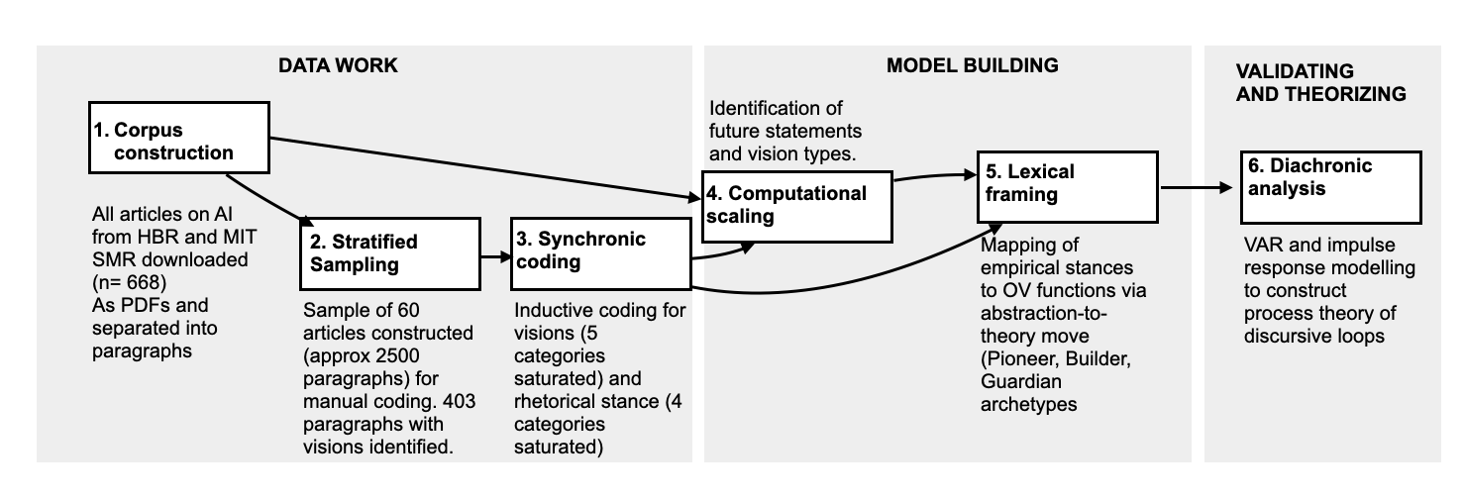
Figure 1: Overview of the computational theory construction process. Steps follow the iterative processes of computationally intensive theory development {Berente et al., 2019, #270025}, organized into three phases {Günther et al., 2026, #126401}. The pipeline curates practice, method, and theoretical lexicons across the three phases

Corpus and research setting
This study examines how vision types of artificial intelligence (AI) interact within practitioner-oriented discourse. The empirical setting comprises two influential managerial outlets: namely Harvard Business Review (HBR) and MIT Sloan Management Review (SMR), which sit between scholarship and practice and help legitimize emerging technologies for executive audiences. We analyze the 2014 to early 2025 period, capturing the diffusion of machine learning, the emergence of deep learning at scale, and the 2023-2024 surge of generative AI. We used both online and print publications. Even if a story was republished online or in a later issue of the magazine, we considered this a boost of the signal and included both. We accessed the PDFs using semi-automated script on the EBSCO Host and Proquest databases and downloaded all the PDFs. We retrieved the text from the PDFs and split the text into paragraphs detected by an algorithm. The unit of analysis is the paragraph; our focus is on future-oriented statements that imagine, prescribe, normalize, or constrain AI-related futures. In the next stage, we started constructing and working with a sample that was manageable for manual processing.

Phase 1: Data Work and Interpretive Grounding
The initial phase of this study follows the Data Work stage of the Dimensionalization and Category Surfacing (DCS) process {Günther et al., 2026, #126401}. This phase is dedicated to the collection, normalization, and interpretive grounding of the corpus to ensure that subsequent computational scaling remains theoretically anchored {Günther et al., 2026, #126401}. Our empirical setting comprises two influential executive-facing outlets: Harvard Business Review(HBR) and MIT Sloan Management Review (SMR). These venues are selected because they function as critical promissory organizations {Pollock and Williams, 2010, #250181} that manage the "business of expectations" by curating attention cues and response repertoires for managerial audiences. The corpus covers the decade from March 2014 to early 2025, capturing the full trajectory of AI’s maturation—from early machine learning applications to the contemporary surge of generative AI.
In a move to increase the rigor of our qualitative grounding, we define the paragraph as our primary unit of analysis. This granular focus allows us to capture specific future-oriented statements that imagine, prescribe, or constrain AI futures. Those statements are frequently obscured when analyzing discourse at the article level. Following the primacy of theoretical lexicons approach , we utilize Organizing Vision (OV) theory as a sensitizing concept {Bowen, 2006, #104580}. This ensures that the meaning system guiding our data reduction is grounded in established theory rather than emerging from a purely inductive process {Günther et al., 2026, #126401}.
To develop a robust theoretical rubric, we constructed a stratified sample of 60 articles, yielding approximately 2,600 paragraphs for manual coding (see Table 2). We adopted a temporal bracketing strategy to ensure this sample reasonably represented the uneven distribution of AI discourse over the decade, segmenting the period into seven distinct "buckets". Through iterative passes of deep reading, we identified 403 paragraphs that explicitly narrated or implied a future for AI. We then performed open and axial coding to execute an abstraction to pattern move. This process surfaced two core dimensions of the discourse: Vision Content (the five thematic vision types of what AI is envisioned to be) and Rhetorical Stance (the four distinct modes of how these visions are delivered: Opening, Mobilizing, Controlling, or Normalizing). This thematic coding established the set of saturated labels required to scale our analysis across the full corpus in the subsequent phase.
Table 2: Stratified sample

Time bin | Notes | Articles | Sample | Vision Paragraphs
2014 | Early | 9 | 3 | 21
2015 |  | 12 | 3 | 50
2016–2017 | 2016–2017 | 82 | 9 | 81
2018–2019 |  | 102 | 9 | 103
2020–2021 | Covid | 118 | 9 | 18
2022–2023 | Recent | 149 | 12 | 68
2024–2025 | Most recent | 196 | 15 | 62
Total | — | 668 | 60 | 403

We thematically coded the set of 403 paragraphs to derive (a) types of visions that are imagined under the label AI. We started by open coding and summarizing each paragraph into a brief statement in the form “This paragraph imagines a future where….” A move consistent with open coding in Grounded theory or summarizing coding {Saldana, 2021, #98981}.We aggregated these visions into five vision types by coding axially {Charmaz, 2014, #295391}. We checked the resulting categories and ensured that they align with the notion of vision types as shared typifications of imagined futures within the broader organizing vision{Swanson and Ramiller, 1997, #75628}. The five vision types are described in the first section of the results section.
When working on the categorization of vision types, we noticed that it is not just the content that matters. The imagination about the future can be delivered in a variety of formats. The OV theory helped us sensitize this intuition. Swanson & Ramiller (1997) emphasize that organizing visions operate but by providing interpretive frames that orient meaning and enable collective mobilization, providing demythologizing talk or tools for legitimization. This attention to the discursive construction of visions suggests that it is not only what the future is imagined to be that matters, but also how such imaginations are delivered.

We started coding for how the paragraphs deliver the future. To do so, we applied an analogical process (open coding, axial coding) to derive a typology of what we term rhetorical stances or how those futures are delivered. We identified four distinct rhetorical stances through which future-oriented visions are delivered. Opening is speculative talk that highlights what might happen without urging action, reassurance, or oversight; it widens the imaginative horizon by naming new possibilities or signalling historical thresholds. Mobilizing is normative "how-to" language that urges proactive action or strategic response, providing scripts, playbooks, and sequenced guidance that convert ambiguity into executable organizational commitments. Normalizing is reassuring talk that presents change as smooth, incremental, and manageable, framing AI adoption as a natural extension of existing practice. Controlling is cautionary language that warns about risks, ethical concerns, or institutional liabilities and advocates for oversight, governance, or deferral, specifying the conditions under which action is acceptable. A single vision can be delivered in any of these stances; it is the combination of vision type and rhetorical stance that determines the archetype assignment (Table 3). Appendix E provides an index of all cited practitioner articles

Having derived typologies of both vision content and rhetorical stance through open and axial coding, we then assessed their robustness by testing whether they could be reliably recognized at scale. We describe the computational scaling in detail in the following sub-section. Here, we just note that the computational scaling provides an additional validation of the robustness of our categories beyond the standard claim of theoretical saturation (which we also reached on the stratified sample). Vision categories proved machine-recognizable with satisfactory performance (F1 = 0.61), while the classifier distinguishing future-oriented discourse achieved strong accuracy (F1 = 0.84). Moreover, we needed to formalize the codebook when we developed an prompt for classification by language models which is available as Appendix A. These results provide evidence that the categories are not only internally coherent but also externally recognizable, offering a computational validation of the qualitative coding.

We also exploratively coded for general topic (open code), for valence (positive, negative), for temporal distance (near future, distant future, speculative future), level of analysis (individual, team, company, society) and other variables that we decided not to integrate in the subsequent analyses. This thematic coding establishes a set of saturated labels that we scale across the full corpus in the next stage.

Phase 2: Model Building and Computational Scaling
Following the interpretive grounding, the second phase of our methodology focuses on Model Building and Pattern Surfacing {Günther et al., 2026, #126401}. In this phase, we utilize computational techniques as extended human abilities to scale the inductively derived categories across the entire 10 year corpus {Berente et al., 2022, #68784}. This scaling is not a neutral technical task but a deliberate analytical move that maintains the primacy of the theoretical lexicon established in the previous stage {Hannigan et al., 2022; Günther et al., 2026, #126401}.
We first operationalized the detection of future oriented paragraphs by training a supervised SetFit {Tunstall et al., 2022, #71244} classifier on 403 positive examples from our manual coding and 403 randomly sampled negatives. The model achieved a held out F1 score of 0.84, and its deployment across the corpus yielded 7,127 paragraph instances that construct or prescribe AI futures. To identify the rhetorical stances within this future gated set, we employed an ensemble labeling strategy using three large language models (LLMs), specifically OpenAI, Claude, and Gemini, facilitated by few shot prompting. This approach ensures lexical alignment by providing the models with clear theoretical definitions and anchor examples derived from our OV informed codebook. We aggregated these labels through a majority vote across the three models, reaching a Fleiss’ kappa of 0.64 and pairwise agreement exceeding 72 percent. Full agreement metrics and error analysis are reported in Appendix B.

To ensure our computational scaling remained theoretically anchored, we executed an Abstraction to Theory move by mapping these rhetorical stances to the core mechanisms of the literature on organizing visions. As summarized in the stance definition table (Table 1), we gave primacy to the theoretical lexicon of Organizing Visions (OV) to "script" the model's interpretative boundaries. Specifically, we mapped the Pioneer stance (OV: Interpretation) to Issue Framing, as both functions broaden the search for what is considered technologically possible. We mapped the Builder stance (OV: Mobilization) to Action Scripts, which translate visions into the routines and procedures required for execution. Finally, we mapped the Guardian stance (OV: Legitimation) to Priority Rules, which function as the evaluative gates and thresholds that authorize or defer action.
The aggregation from five vision types and four stances to three archetypes constitutes a lexical framing move: we translate the empirical categories of the practice lexicon into the theoretical lexicon of Organizing Vision functions (interpretation, mobilization, legitimation), giving primacy to the theoretical lexicon while preserving the practice-grounded distinctions that generated them.

Table 3: Generic vision archetypes as combinations of vision type and rhetorical stance

Vision Type | Opening | Mobilizing | Normalizing | Controlling
Open Horizons, Unstable Ground | Pioneer | Pioneer | Pioneer | Guardian
Empowered but Exposed | Pioneer | Builder | Guardian | Guardian
Seamless but Concentrated | Pioneer | Builder | Pioneer | Guardian
Transformed or Left Behind | Pioneer | Builder | Pioneer | Guardian
Guided but Fragile | Pioneer | Guardian | Guardian | Guardian

This theoretical scripting provided the explicit rule-set (Table 3) used to aggregate our granular labels into three higher-order archetypes: Pioneering, Building, and Guardian. This theoretical aggregation reduces dimensionality and focuses our subsequent modeling on the generic discursive roles that sustain hype across emerging technologies. Crucially, the aggregation also absorbs the most likely source of labeling noise. For three of the five vision types (Open Horizons, Seamless but Concentrated, and Transformed or Left Behind), the Opening and Normalizing stances (which is the pair on which LLM classifiers most frequently disagree) map to the same archetype, so misclassification between them does not propagate into the downstream analysis. For the remaining two vision types (Empowered but Exposed, Guided but Fragile), the confusion shifts paragraphs between Pioneer and Guardian, which introduces noise into the very axis where we report our dominant interaction. We validated this archetype mapping through a blind audit on a stratified sample, where human archetype codes derived via the mapping rubric agreed closely with direct human identification (accuracy 0.898, κ 0.843). While the human-to-model agreement reached a moderate Fleiss' kappa of 0.55 to 0.59, we argue, consistent with the trustworthiness framework, that this is sufficient for surfacing corpus-level structural dynamics. The high internal consistency among humans confirms that the underlying theoretical rubric is robust and auditable. Following the principle that theory construction is an exploratory rather than confirmatory endeavor {Berente et al., 2022, #68784}, we treat these agreement levels as sufficient for surfacing corpus-level structural dynamics.Table 4 provides illustrative excerpts for each combination of vision type and rhetorical stance, grounding the archetype assignments in the source material
Table 4: Sample excerpts of data across vision types and rhetorical archetypes

Organizing Vision  Theoretical Archetype | 1. Open Horizons, Unstable Ground: AI as a regime-shifting event with vast, uncharted potential. | 2. Empowered but Exposed: AI augmenting human capabilities while introducing risks of displacement. | 3. Seamless but Concentrated: Hyper-efficient AI integration that creates data monopolies and concentrated power. | 4. Transformed or Left Behind: The existential competitive imperative to adopt AI or face rapid obsolescence. | 5. Guided but Fragile: The brittleness of AI systems requiring robust ethical frameworks and governance.
THE PIONEER  (Interpretation) | [Stance: Opening] "We are at the beginning of a golden age of AI. Recent advancements have already led to invention that previously lived in the realm of science fiction..." (HBR, 2014)  Ref: [P-01] | [Stance: Opening] "As the size and complexity of LLMs increase, they can exhibit ‘emergent properties’—powerful new abilities, such as advanced reasoning, that they weren’t trained for but that nevertheless appear after you tailor LLMs..." (HBR, 2017) Ref: [P-03] | [Stance: Opening] "The platform will gather and deliver information, and the assistant will be the consumer’s interface with home systems, appliances, and other machines... the portal to an infinite shopping mall of goods and services." (HBR, 2018)  Ref: [P-05] | [Stance: Opening] "Automation anxiety reached new heights... published a paper estimating that 47% of all U.S. jobs were ‘at risk’ of being computerized... the pace at which AI and deep learning technologies have been advancing isn’t ebbing concerns over a future of disappearing work." (HBR, 2015)  Ref: [P-02] | [Stance: Opening]  "Some observers — scholars, managers, policy makers — believe that following responsible AI development principles is a valid and effective approach to injecting ethical considerations into AI systems." (MIT SMR, 2022) Ref: [P-04]
THE BUILDER  (Mobilization) | (N/A: This vision's focus on vast, unstable potential does not yield concrete action scripts) | [Stance: Mobilizing]  "AI will not replace managers, but managers who use AI will replace the managers who do not..." (HBR, 2023)  Ref: [P-06] | [Stance: Mobilizing] "Brands will need to shift the focus of their marketing from consumers to AI platforms, seeking to influence platforms in order to get preferential positioning on AI assistants." (HBR, 2022)  Ref: [P-05] | [Stance: Mobilizing]  "The competitive landscape is being redrawn. Companies that fail to place AI at the core of their strategy risk rapid obsolescence..."(SMR, 2019)  Ref: [P-08] | (N/A: This vision's focus on fragility inherently defers mobilization in favor of legitimation)
THE GUARDIAN  (Legitimation) | [Stances: Controlling] "Algorithmic decision-making and artificial intelligence (AI) hold enormous potential... but we worry that the hype has led many people to overlook the serious problems of introducing algorithms into business and society." (HBR, 2018)  Ref: [P-09] | [Stances: Controlling]  "A candidate should also know if AI is making the final decision or if a human is going to work with the data. HR managers and hiring platforms should also work together to develop greater guidelines..." (HBR, 2022)  Ref: [P-10] | [Stance: Controlling] "The concentration of those functions within a few platforms will give their owners enormous clout... Consumer companies that feel that large retailers like Walmart wield too much power today will be even more alarmed by the might of AI platforms." (HBR, 2022)  Ref: [P-05] | [Stance: Controlling] "Algorithms, if left unchecked, can exacerbate bias and misinformation... The value that scale delivers eventually tapers off in traditional operating models, but in digital operating models, it can climb much higher." (HBR, 2020)  Ref: [P-12] | [Stances: Controlling]  "As AI systems become more autonomous, the need for robust ethical frameworks and transparent decision-making processes becomes critical to prevent catastrophic failures..." (SMR, 2022)  Ref: [P-04]

Phase 3: Pattern Discovery through Temporal Interaction Modeling
The final phase of our methodology focuses on pattern discovery and Theorizing, where we move from the identification of latent patterns to the construction of a process theory regarding the attention ecology. To resolve the question of how these discursive archetypes interact over time, we adopt a Temporal Dynamics Framework specifically designed for digital trace data {Kishore et al., 2024, #216821}. This phase treats the longitudinal shares of the Pioneering, Building, and Guardian archetypes not merely as frequency counts, but as a system of endogenous variables that mutually shape the field’s trajectory.
To model these mutual influences, we employ vector autoregression (VAR), a time-series technique widely used in economics and increasingly in organizational research {Kishore et al., 2024, #216821}. A VAR models each variable in a system as a function of its own past values and the past values of all other variables in the system. In our case, the monthly shares of Pioneer, Builder, and Guardian discourse each depend on their own recent history and on recent movements in the other two. This allows us to ask, for example, whether a surge in Pioneer discourse in one month predicts a rise in Guardian discourse in subsequent months, while simultaneously accounting for Guardian's own momentum. Two diagnostic tools accompany the VAR. Impulse response functions (IRFs) trace how a one-time shock to one archetype ripples through the others over the following months, revealing the direction, magnitude, and duration of cross-archetype influence. Forecast error variance decomposition (FEVD) quantifies how much of the variation in each archetype over a given horizon is attributable to shocks originating in the others versus in itself. Together, these tools allow us to move from observing that archetypes co-occur to specifying the structural feedback among them. Because our three archetype shares are compositional (they sum to one), we apply an isometric log-ratio transformation before estimation to avoid spurious negative correlations; full technical details are reported in Appendix C.
The descriptive time series reveals that the three archetypes fluctuate over the decade; the VAR adds to this by specifying how they respond to each other, at what pace, and with what asymmetry which bridges the difference between documenting a taxonomy and constructing a process theory.
Alongside the VAR, we employ a Temporal Bracketing Strategy {Kishore et al., 2024, #216821} to validate whether the observed dynamics hold across distinct periods of the discourse. We identify the launch of ChatGPT in November 2022 as a critical exogenous shock that allows us to observe how the discourse ecology resets its internal logic. This bracketing enables us to qualitatively compare the stability of the attention loops before and after a major technological disruption, ensuring that our findings are grounded in the actual lived history of the field.

To ensure the trustworthiness of these temporal patterns, we performed a series of robustness checks focused on denominator integrity. We tested our models against an original only corpus, excluding republications, to ensure the observed dynamics were not artifacts of the editorial schedule. Finding that the structural interactions remained invariant across these specifications, we conclude that the model successfully captures the underlying recurrent dynamics of the AI organizing vision ecology.

Linking the interpretive grounding of Phase 1 with the scalable coverage achieved through computational abstraction in Phase 2 allows us to move beyond static categorization and toward process theory construction in Phase 3 {Kishore et al., 2024, #216821}. This integrated design enables us to theorize the dynamic ecology of attention, revealing how multiple vision types co-exist and co-evolve under conditions of extreme technological ambiguity {Grodal et al., 2024, #248950}. By modeling the longitudinal interactions between speculative openings, mobilizing deployments, and guardianship framings, we provide an auditable account of the structural loops that sustain field-level hype over time {Günther et al., 2026, #126401; Berente et al., 2022, #68784}.

Results: Dialectic of Novelty and Control in Organizing Vision Ecology
Given the complexity of the analysis, that combines qualitative and computational approaches to explore the patterns in the discourse, we took inspiration from advice for presenting process research and compose the results in a model-led order{Berends and Deken, 2021, #224145}. After briefly outlining the corpus in a descriptive sense in the following sub-section, we present the results as a components of the emergent model of discursive loops in ecology of Organizing Visions. This way of presenting helps us directly address our theoretically motivated research aim and allows the reader to absorb both the qualitative and computational evidence (from Vector Auto Regression and Impulse response framework) as they jointly contribute to the patterns that form our theoretical generalization.

Descriptive Landscape: The Ten-Year Trajectory of AI Discourse
We begin our analysis by tracing the ten-year history of executive AI discourse to provide a clear narrative foundation for our findings. As illustrated in the three-panel overview in Figure 2, the investigated decade of discourse on AI is a dynamic ecology where the very definition of AI expands and reconfigures alongside specific technological milestones.
Before tracing this trajectory, we briefly define the five vision types that emerged from our synchronic coding and that populate Panel III. Open Horizons, Unstable Ground frames AI as a regime-shifting event with vast, uncharted potential or a historical discontinuity whose ultimate scope remains radically uncertain. Empowered but Exposed imagines AI augmenting human capabilities while introducing new vulnerabilities: individuals and organizations perform existing tasks more efficiently but face risks of displacement, surveillance, and erosion of autonomy. Seamless but Concentrated visions hyper-efficient AI integration that creates frictionless digital experiences for users while concentrating data, infrastructure, and market power in a few dominant platforms. Transformed or Left Behind casts AI as an existential competitive imperative: organizations must fundamentally restructure or face rapid obsolescence. Guided but Fragile foregrounds the brittleness of AI systems and the institutional safeguards (e.g. ethical frameworks, regulatory guardrails, and governance mechanisms) required before adoption can proceed. These five types are not mutually exclusive within the corpus; a single article may invoke several, and the ecology's dynamics arise from their coexistence and interaction over time.
Looking at overall Field Intensity (Panel I), we observe a steady accumulation of managerial attention over the decade, punctuated by acute technological shocks. In the early years of this timeline, the conversation was heavily skewed toward speculative possibility. During this period, the Discourse Ecology (Panel II) was structurally dominated by the Pioneer archetype, which commanded nearly 80% of the conversational space. Executives were not yet deploying AI; they were attempting to interpret it as a regime-shifting event with vast, uncharted potential (what we term the Open Horizons, Unstable Ground vision, see Panel III).
However, this initial speculative homogeneity was soon disrupted as the underlying technology achieved its first major commercial milestones. The discourse experienced its first acute intensification around the AlphaGo / Deep Learning (DL) peak in 2016, closely followed by the publication of the foundational "Attention Is All You Need" architecture in 2017. While these events created a visible swell in overall volume (Panel I), their true impact was a structural reconfiguration beneath the surface. As Panel II demonstrates, these twin breakthroughs triggered a multi-year contraction for the Pioneer archetype, making way for the steady, endogenous rise of the Guardian and Builder stances. As AI transitioned from an abstract concept into applied systems, the Lexical Grounding (Panel III) shifted accordingly: the field began to focus on the brittleness of AI systems that required robust ethical governance (the Guided but Fragile vision) alongside the existential competitive imperative to adopt AI or face rapid obsolescence (the Transformed or Left Behind vision theme).
As the decade progressed toward the GPT-3 release in 2020, the discourse matured into a state of institutional reality. Despite a temporary dip in overall volume (Panel I), the ecology had evolved into a persistent, balanced dialectic between Pioneering novelty, Guardian control, and Builder mobilization (Panel II). During this middle era, the definition of AI expanded further to include concerns over hyper-efficient integration creating data monopolies and concentrated power (the Seamless but Concentrated vision, Panel III). The field was actively seeking to establish operational and ethical boundaries around increasingly powerful models.
The temporal trajectories of the vision types provide event-anchored validation: Open Horizons surges around the 2016 AlphaGo breakthrough, Guided but Fragile rises following the Cambridge Analytica fallout and the EU AI Act, and Empowered but Exposed dominates the post-ChatGPT period. These alignments between discursive patterns and recognized field-level events corroborate the construct validity of the inductively derived categories.

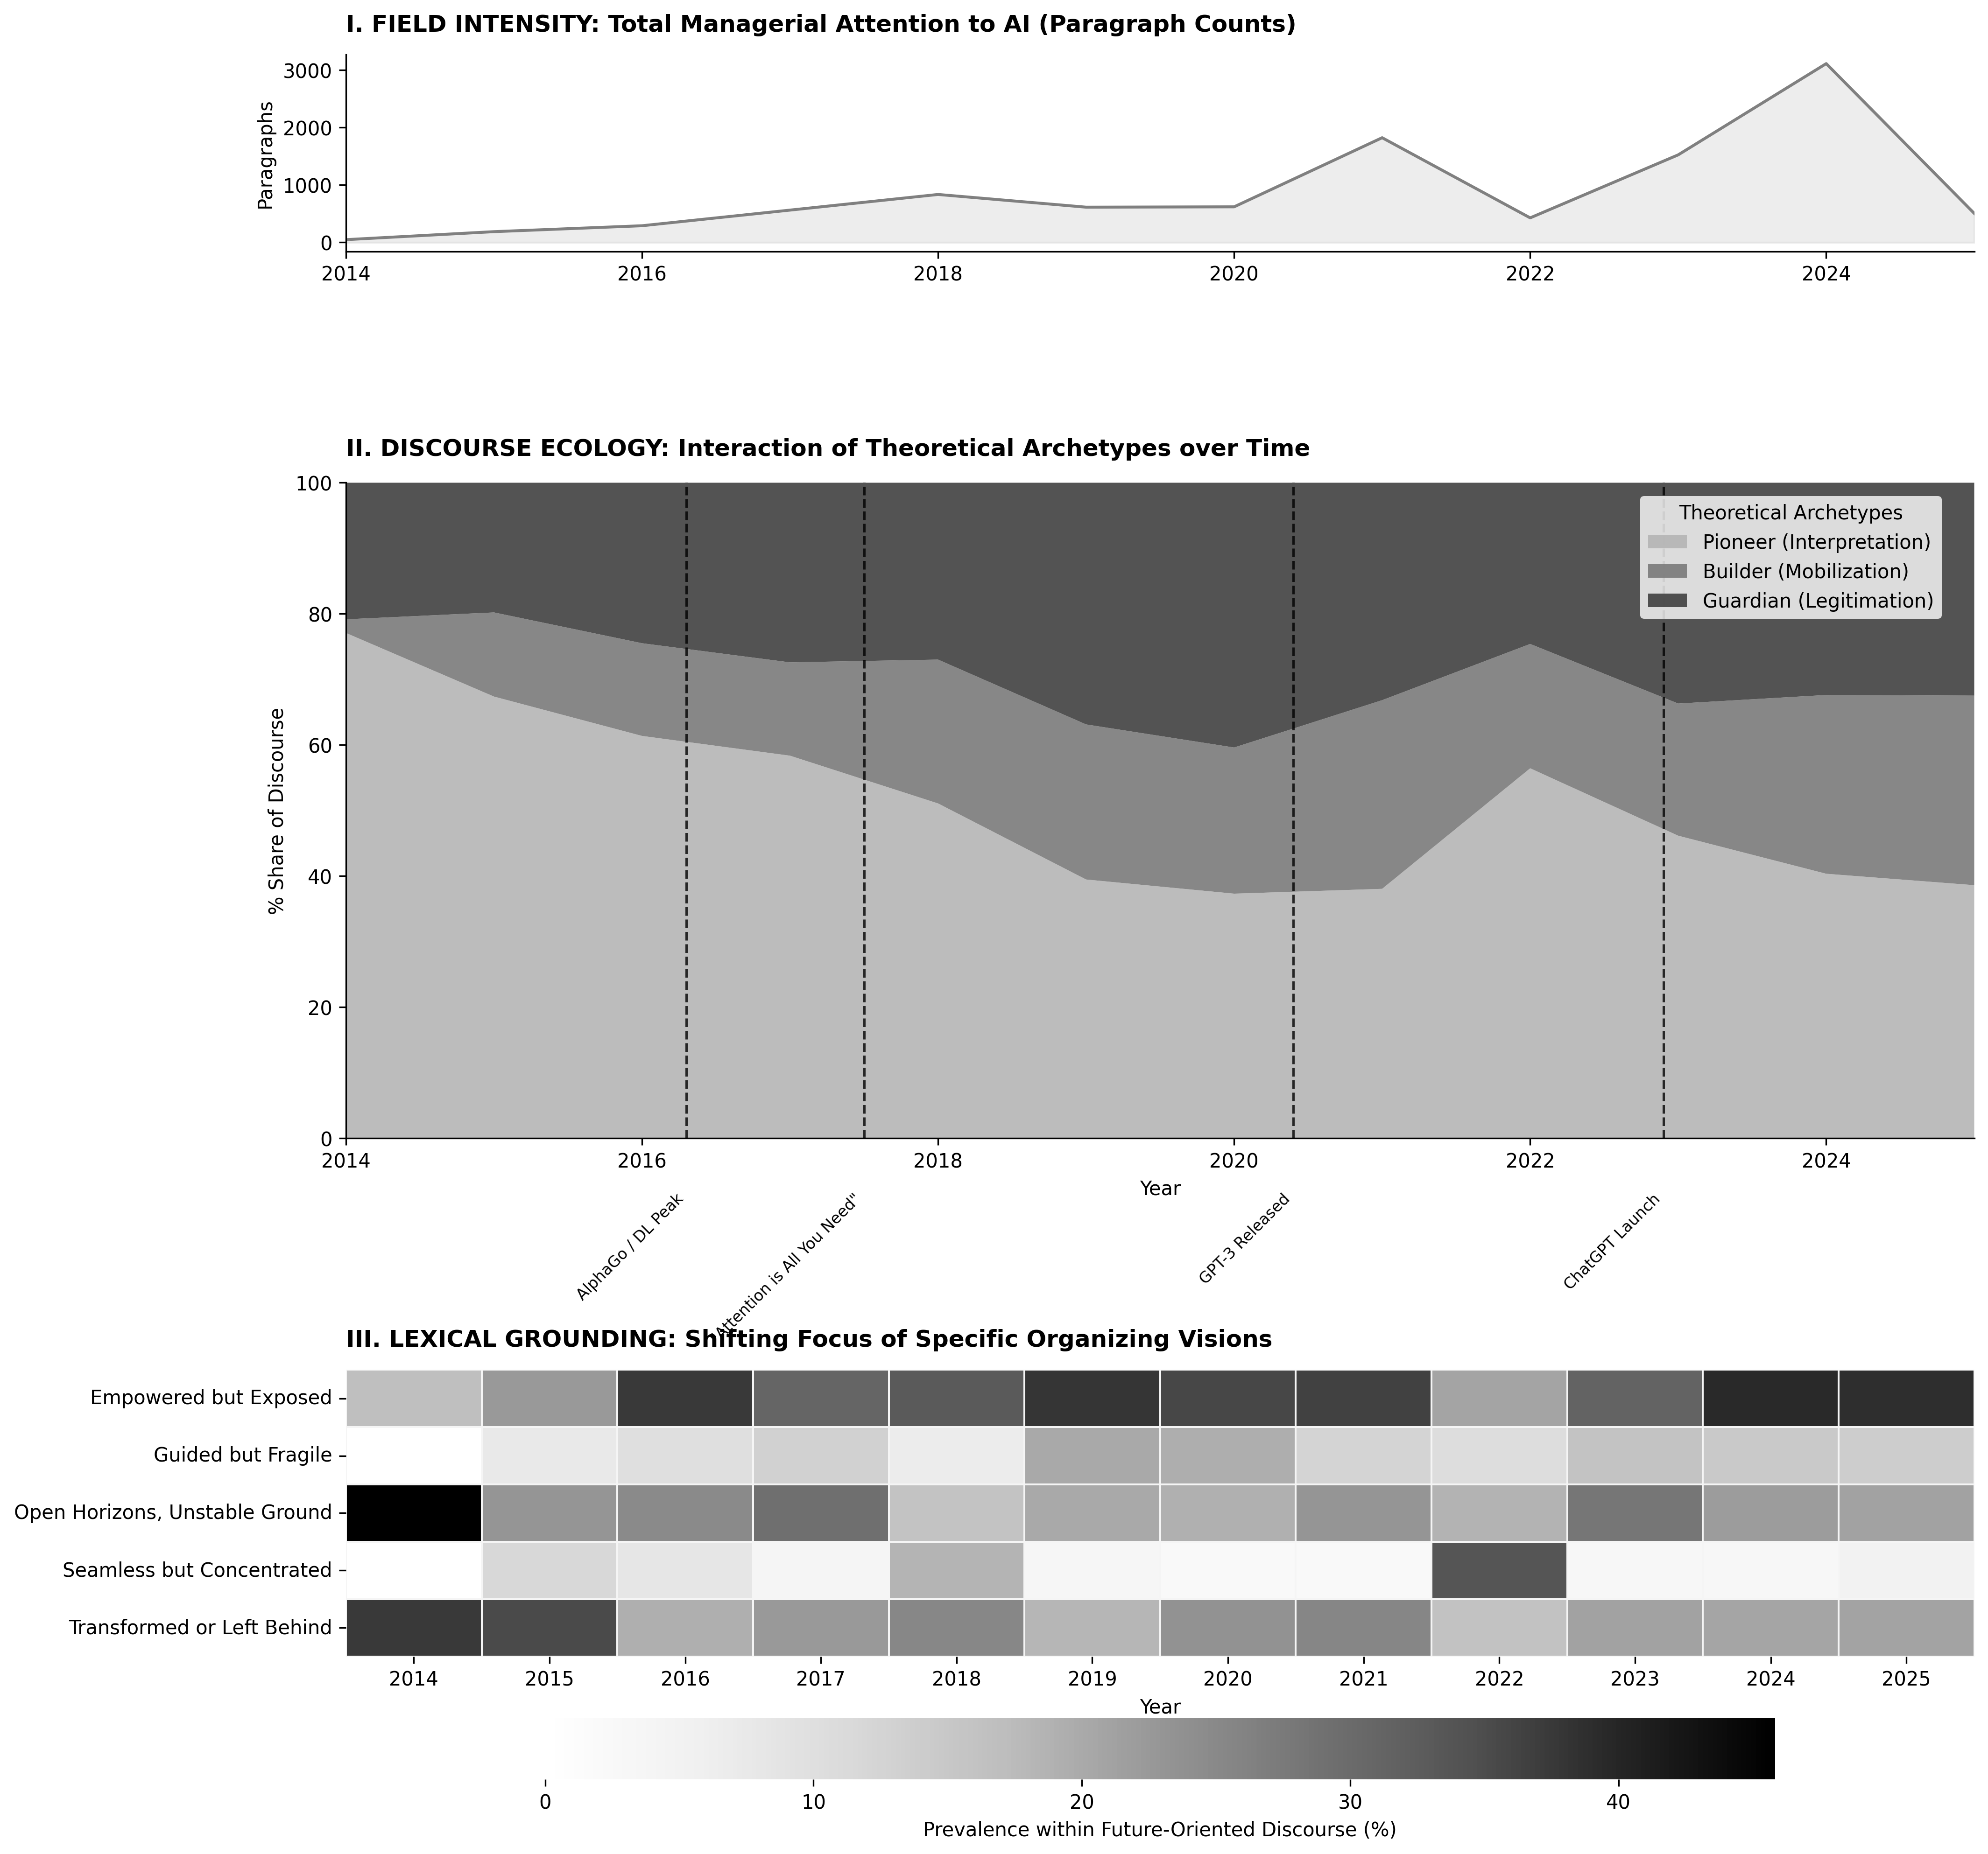
Figure 2 : Descriptive overview of the corpus
This steady institutionalization was suddenly destabilized in late 2022 by the ChatGPT launch. As Panel I shows, this historic milestone triggered a massive, unprecedented surge in overall executive attention. Crucially, Panel II reveals this event forced a renewed Interpretive Opening when the Pioneer archetype spiked upward once again as the field scrambled to redefine AI as an accessible, generative tool. Yet, reflecting a decade of discursive learning, this Pioneer surge did not occur in a vacuum; it was instantly matched by intense Builder and Guardian mobilization. At the end of the studied period, the discourse was overwhelmingly focused on how AI augments human capabilities while introducing new risks of displacement (the Empowered but Exposed vision, Panel III). This indicates that AI hype was no longer just about untethered possibility, but the intense, simultaneous friction between augmented capability, strategic execution, and risk mitigation. This continuous, ten-year renegotiation of meaning sets the stage for our model-led composition, where we unpack the structural loops that drive these cyclical shifts.

Model-Led Synthesis: Dialectic of Novelty and Control
Building on the descriptive trajectory of the last decade, we move to the core theoretical output of our analysis: the Model of Discursive Loops. We adopt a model-led composition for this section {Berends and Deken, 2021, #224145}, "front-loading" our abductive synthesis to provide the theoretical scaffold required for readers to understand the complex empirical dynamics that follow. By revealing the "plot" of our findings upfront we ensure that the subsequent interaction modeling and qualitative narratives are read not as isolated events, but as functional components of an integrated process theory. This model, depicted in Figure 3, theorizes the executive attention ecology as a dynamic system that navigates the inherent tension between novelty and control through three distinct structural interactions. The linkages are based on Implulse Response analysis depicted in Figure 4 and visually and summarized numerically in Table 5.
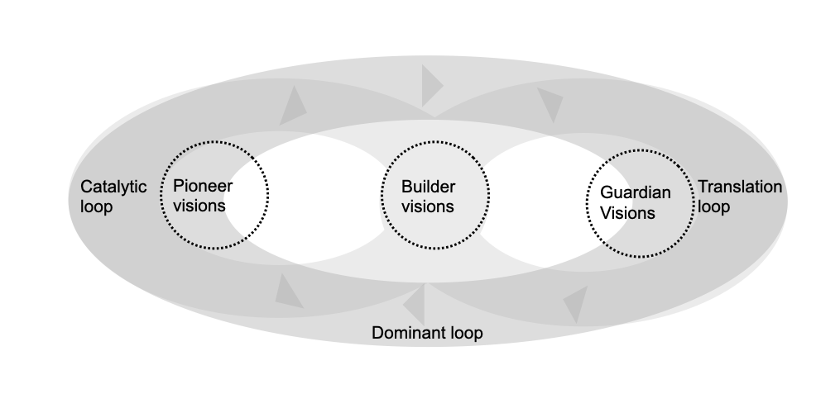
Figure 3: Model of loops in discourse on emerging technologies
The primary axis of this ecology is the Dominant Loop, which characterizes the structural backbone of the AI organizing vision. This loop represents the direct, endogenous interaction between the Pioneer and the Guardian, capturing a dialectic where every speculative opening is structurally followed by a legitimating response. In terms of Organizing Vision theory, this interaction functions as a developmental engine: Pioneering interpretation provokes Guardian legitimation, creating a regular oscillation between expansion and containment. As Pioneers generate excitement around radical horizons, Guardians respond with counter-narratives that "demythologize" or contextualize those possibilities, ensuring the vision remains institutionally grounded. This loop demonstrates that the "hype" surrounding AI is not a singular surge but a persistent conversation between those who broaden the search for what is possible and those who set the evaluative thresholds for what is acceptable.
The three-loop model constitutes our theoretical abstraction from the computationally surfaced patterns. The IRFs and FEVD are empirical generalizations; the model situates these patterns within the theoretical lexicon of OV theory by explaining how the functions of interpretation, mobilization, and legitimation interact as a dynamic ecology
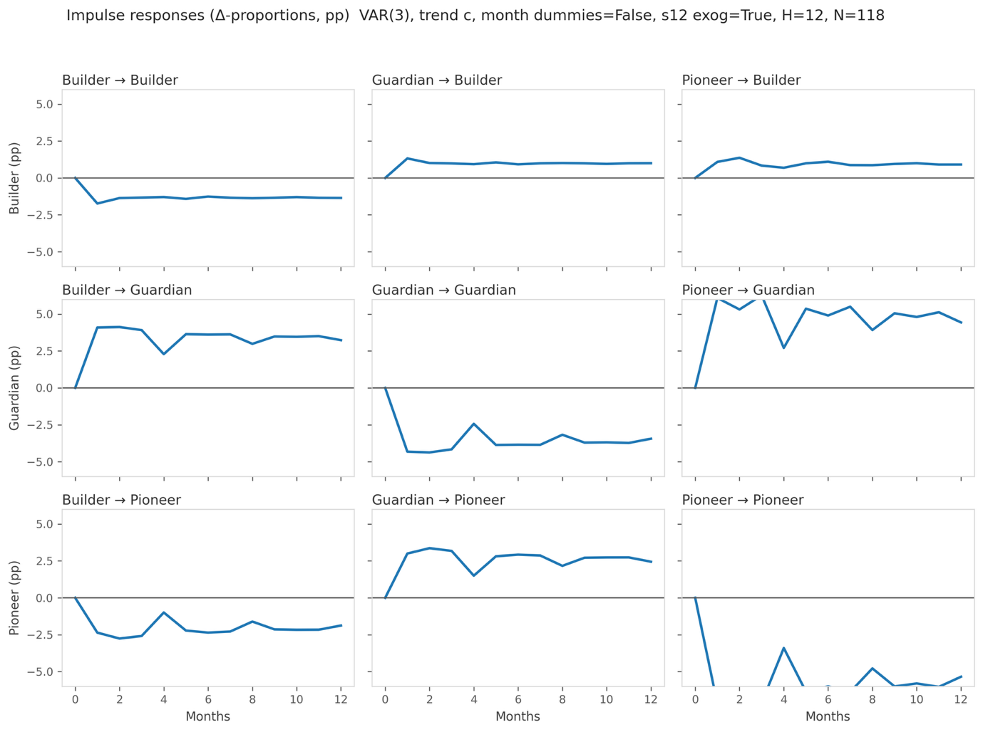

Figure 4: Impulse responses (Δ-proportions, percentage points) from a VAR(3) estimated on first-differenced and deseasonalized ILR coordinates of the three archetype shares. Trend ”c”; exogenous control: seasonal lag (ΔILR_{t−12}). Shocks are generalized impulses scaled to 0.30 s.d. for cross-panel comparability (one-s.d. responses are proportionally larger). IRFs were back-transformed to percentage-point equivalents at the sample mean composition. Y-axes are fixed to ±6 pp; month 0 equals the pre-shock baseline

Nested within this primary dialectic are the Translating and Catalytic Loops, which identify how the field resolves these high-level tensions through the Builder archetype. The Translating Loop connects guardianship to mobilization, capturing the dynamic wherein cautionary concerns regarding "how to comply" or "how to govern" are amplified when they are echoed in prescriptive, actionable terms. Simultaneously, the Catalytic Loop represents a pendulum-like movement where Pioneering novelty is translated into normative "action scripts." Here, the Builder serves as a temporary bridge, sifting through speculative potential to create the routines of implementation. Together, these loops reveal that the Builder is positioned "in the middle" of the ecology, surging precisely when Pioneering and Guardianship visions move out of sync. This model provides an integrated perspective—an overview of the findings as a whole—which we now support through the structural interaction parameters and detailed qualitative grounding in the following sections.

The Pioneer: Speculative Openings and the Dominant Loop
The Pioneer archetype performs the foundational interpretive work of the organizing vision by expanding the managerial search space and reframing technological ends. As the primary engine of the Dominant Loop (Between Pioneer and Guardian), the Pioneer reduces uncertainty by rendering radical technological change intelligible to executive audiences. This role is primarily fueled by the Open Horizons and Empowered but Exposed visions, which rely on a speculative "Opening" stance to interpret AI as a regime-shifting event rather than a mere tool.
Lexical grounding for this interpretive move is found in early discourse that used staggering metrics to broaden the field's sense of possibility. In 2014, the vision was narrated as a fundamental expansion of human expertise, as seen in this account of AI in oncology:
"How many oncologists could hope to read, much less remember, the 600,000 pieces of medical evidence and two million journal pages describing research and trials on lung cancer that have been fed to Watson? With all this information, Watson lists possible courses of treatment and assigns levels of confidence to each." (Ref: [P-01]; Swap & Leonard, 2014
As the decade progressed, this interpretation shifted from specific capabilities to a more general sense of reaching a profound historical threshold. By 2015, the discourse was already normalizing the arrival of "thinking machines" and framing the current era as a definitive break from the past:
"Artificial Intelligence (AI) is an idea that has oscillated through many hype cycles over many years, as scientists and sci-fi visionaries have declared the imminent arrival of thinking machines. But it seems we’re now at an actual tipping point." (Ref: [P-14]; Power, 2015)
The evidence of this archetype’s role as an attentional catalyst is revealed in our temporal and interaction analyses. Our longitudinal trace (Figure 2) shows that Pioneering moves arrive as "interpretive shocks," most notably during the 2016 deep learning peak and the late 2022 "Renewed Interpretive Opening" triggered by ChatGPT. Our modeling (Table 5) confirms that these shocks do not exist in a vacuum; a shock to Pioneer novelty is regularly followed by a +6.3 percentage point surge by month 3. Furthermore, the FEVD analysis shows that Pioneer shocks are the dominant source of Guardian variance, accounting for approximately 67% of Guardian’s forecast error on the Pioneer–rest axis at the 12-month horizon. To our theorizing, this is providing directional evidence for claims that speculative openings are systematically followed by the reactive construction of institutional guardrails.

The Guardian: Legitimation and the Translating Loop
The Guardian archetype serves as the dialectical counterbalance to Pioneering speculation, performing the legitimation work required to secure a social and institutional license to operate. Operating through the Guided but Fragile and Seamless but Concentrated visions, this role asserts "priority rules" that filter organizational attention toward risks and safeguards. The Guardian does not merely react to the future; it sets the evaluative thresholds that authorize or defer organizational action. By "demythologizing" the hype, the Guardian ensures the vision remains grounded in prevailing norms and reputable authorities.
Qualitative grounding for this role reveals a discourse centered on the brittleness of the vision and the "gambling" of institutional reputation. In 2016, the discourse already highlighted the potential for technology to serve as an internal auditor for human fallibility:
"There is a great potential for machines to alert us to bias," Rossi notes. "We need to not only train our algorithms but also be open to the possibility that they can teach us about ourselves." (Ref: [P-19]; Satell, 2016)
This cautionary tone escalated into existential warnings by 2017, with authors arguing that in an AI-mediated workplace, the lack of consequences for machines creates a fundamental responsibility gap:
"But in an AI workplace, if an expert decision-making system wrongly recommends one course of action over another, the computer suffers no consequences. AI systems are gambling only with the fates of others, never with their own." (Ref: [P-16]; Gray, 2017)
The most critical finding regarding the Guardian is its structural interaction with the Builder, theorized as the Translating Loop (Between Guardian and Building). Our interaction modeling (Table 5) shows that a shock to Guardian caution is followed by a rapid and robust Builder response of +1.3 percentage points within the first month. The FEVD analysis provides even more striking evidence, showing that Builder mobilization loads 66.5% on the Builder–Guardian axis at the 12-month horizon. This provides evidence for the "Wedge Effect," demonstrating that institutional constraints do not stifle the vision but instead create a specific form of "attentional pressure" that the field resolves by developing actionable protocols.
Table 5: Computational evidence for the discursive loops

Theoretical Loop | Interaction Sequence | IRF Peak Effect (pp change) | Variance Attribution (FEVD @ 12m) | Structural Interpretation
Dominant Loop | Pioneer → Guardian | +6.3 pp (month 3) | 67.1% of Guardian variance loads on the Pioneer–rest axis | Speculative novelty is followed by institutional guardrails
 | Guardian → Pioneer | +3.4 pp (month 2) | 88.4% of Pioneer variance is self-driven; 11.6% loads on the Builder–Guardian axis | Legitimation discourse invites further speculative adaptation
Translation Loop | Guardian → Builder | +1.3 pp (month 1) | 66.5% of Builder variance loads on the Builder–Guardian axis | Institutional constraints are followed by the development of actionable protocols
 | Builder → Guardian | +4.1 pp (month 2) | 32.9% of Guardian variance loads on the Builder–Guardian axis | Normative action scripts reinforce the institutional license to operate
Catalytic Loop | Pioneer → Builder | +1.4 pp (month 2) | 33.5% of Builder variance loads on the Pioneer–rest axis | Interpreted potential catalyzes initial organizational mobilization
 | Builder → Pioneer | -2.8 pp (month 2) | 11.6% of Pioneer variance loads on the Builder–Guardian axis | Solidified action scripts suppress further speculative reframing

The Builder: Mobilization and the Catalytic Loop
The Builder archetype serves as the final discursive bridge, translating abstract interpretations and legitimating constraints into the "action scripts" and coordinated routines required for field-level momentum. The Builder role is most visible when delivering the Transformed or Left Behind vision, as well as the action-oriented facets of the Empowered Partner vision. By focusing on "how-to" templates and maturity models, the Builder converts the field's dialectical tension into executable organizational commitments, sifting through the uncertainty of the Pioneer and the caution of the Guardian to offer a pragmatic path forward.
The Builder stance is identified by a shift in tone from what the technology could be to what the organization must do. For example, when the discourse moves from empowerment to implementation, the focus shifts to specific skills and diagnostic questions required for a successful rollout:
"Ask: ‘What will this new technology require you to do that is new or different?’ You’ll also want to learn more about the skills people already have." (Ref: [P-17]; Karp & Peterson, 2022)
Beyond individual skills, the Builder also mobilizes organizational-scale defenses, turning abstract Guardian risks into concrete operational routines. In 2023, this was manifested in advice to institutionalize adversarial testing and governance capacity, effectively converting "care" into "conduct":
"Companies need to be able to adversarially test their AI systems, especially autonomous agents, and their harm mitigations at scale... Creating company-wide hackathons, dedicated red teams, and external bug bounties are all well-known methods, but they must be continually implemented." (Ref: [P-18]; Baxter & Schlesinger, 2024)
The structural evidence for this "bridging" role is found in our Catalytic Loop (Between Pioneer and Builder) and the bidirectional interactions with the Guardian. Our modeling (Table 5) shows a regular positive response (+1.4 pp at month 2) from Pioneer shocks, indicating that interpretation precedes mobilization. However, the model also reveals a structural "closing of the mind," where Building discourse exerts a negative feedback loop back toward Pioneering (-2.8 pp at month 2). This suggests that once the field settles on specific "how-to" routines, it is associated with reduced speculative reframing in favor of execution. This interaction completes our ecology, illustrating how the AI organizing vision is sustained by a system that recursively balances opening for novelty with closing for action.
Converging evidence from an independent event-study design (Appendix D) shows that Builder's share rises by approximately 10 percentage points in the three months following episodes when Pioneer and Guardian move in opposite directions. By using an independent analytical method, we achieve methodological triangulation, corroborating the VAR-derived patterns through a different approach to the same data.

Discussion
.1. Contribution 1: From Sequential Functions to an Ecology of Attention
- Target Literature: Organizing Vision (OV) Theory (Swanson & Ramiller, 1997; Ramiller & Swanson, 2003).
- The Gap: Extant literature often treats OV functions (interpretation, legitimation, mobilization) as static labels or sequential phases in a technology's lifecycle.
- The Finding: Our VAR analysis demonstrates that these functions operate as endogenous, interacting loops (e.g., Pioneering shocks are followed by a +6.3pp surge in Guardian discourse).
- The Theoretical Shift: We contribute an Ecological Model of Organizing Visions. We theorize that an organizing vision is not sustained by consensus, but by a continuous Dialectic of Novelty and Control. Expansionary interpretation inherently produces institutional caution, ensuring the vision remains grounded even as it explores radical frontiers.
- Extant literature theorizes that on the larger stage of the institutional field, 'mindfulness and mindlessness travel together' as firms navigate the hype of a new technology {Swanson and Ramiller, 2004, #284827}. By modeling the structural dialectic between Pioneer openings and Guardian constraints, our study provides the empirical evidence for this dynamic, demonstrating how an organizing vision matures through the continuous, endogenous friction between speculative momentum and mindful restraint.
the ecology model doesn't just show that the three functions interact dynamically — it also reveals functional specialization within the vision. Some vision types carry interpretation (Open Horizons), others carry legitimation (Guided but Fragile), and mobilization concentrates in the middle strands that can draw on both speculative and cautionary raw material. This means the organizing vision performs its three functions not through each narrative strand doing everything, but through a division of labor across strands. That division is what makes the ecology necessary — no single strand can sustain the vision alone, which is why the interaction dynamics you model actually matter.
5.2. Contribution 2: Translating Constraints and the "Wedge Effect"
- Target Literature: Institutional Entrepreneurship and Strategic Ambiguity (e.g., Denis et al., 2011).
- The Gap: Legitimation (Guardian discourse) is traditionally viewed as a barrier, filter, or "brake" that slows down adoption until risks are mitigated.
- The Finding: The Translating Loop reveals that Builder mobilization loads heavily (66.5% FEVD) on the Builder–Guardian axis, surging specifically when institutional constraints peak.
- The Theoretical Shift: We theorize the Builder as a Discursive Bridge that resolves institutional friction. We demonstrate that constraint does not stifle a vision; rather, constraint breeds action scripts. The Builder translates macro-level existential anxiety into micro-level normative capabilities (e.g., converting "AI is biased" into algorithmic audit routines).
- The Institutional Translation (Carrier vs. Trigger): The findings resolve the binary of whether a technology is a trigger or a carrier of norms by framing it as a developmental loop.
  - The Pioneer introduces AI as a radical trigger for disruption.
  - The Guardian responds with discursive institutional maintenance, demanding compliance with existing norms.
  - The Wedge Effect forces the Builder to do the actual translation work. Therefore, emerging technologies are not inherently born as carriers of norms; they are discursively engineered into carriers through the friction between Pioneer hype and Guardian pushback.

The Wedge Effect: Institutional Constraints as Catalysts for Action Perhaps the most surprising finding of our interaction modeling is the endogenous relationship between legitimation and mobilization, which we term the "Wedge Effect." Traditional linear models of innovation often frame institutional constraints (Guardianship) as friction that slows down adoption. However, our Translating Loop (Table 5) provides computationally grounded support for the finding that shocks to Guardian caution are followed by rapid Builder mobilization (+1.3 pp within one month, capturing nearly 67% of Builder variance). In the context of extreme ambiguity, executive warnings about algorithmic bias or data security do not halt the technology; instead, they act as a wedge that precedes the creation the creation of concrete action scripts. Organizations cannot simply "pause" AI adoption, so institutional pushback paradoxically catalyzes the rapid development of the very compliance routines, auditing frameworks, and implementation structures required to move the technology from the speculative horizon into everyday operations.
5.3. Contribution 3: Hype Resilience and the "Closing of the Mind"
- Target Literature: IT Fashions, Bandwagons, and Hype Cycles (e.g., Baskerville & Myers, 2009; Wang, 2010).
- The Gap: IT fashion literature struggles to structurally explain why certain technologies survive the "peak of inflated expectations" over a decade while others quickly fizzle out under the weight of their own ambiguity.
- The Finding: The Catalytic Loop reveals a negative feedback mechanism (-2.8pp IRF) from Builder mobilization back to Pioneer interpretation.
- The Theoretical Shift: We contribute a structural explanation for Hype Resilience. AI hype endures because the attention ecology possesses a self-regulating mechanism to "close the interpretive window." Once mobilization routines solidify, the field actively filters out new, distracting speculative reframing to favor execution, preventing the vision from collapsing under perpetual ambiguity.
By demonstrating how the field manages the friction between speculative openings and normative closures, we answer recent calls to explicate the temporal mechanisms of entrepreneurial hype {Garud et al., 2026, #187928; Wood et al., 2024, #258847}, providing a structural explanation for how AI hype avoids collapse and sustains resource mobilization despite extreme ambiguity {Rady et al., 2025, #168338}.

Limitations
Our inferences rest on deliberate scoping and modeling choices. We focus on two influential, U.S.-based managerial outlets (Harvard Business Review and MIT Sloan Management Review) because they shape executive sensemaking about ambiguous technologies. That editorial center of gravity is a methodological choice born out of feasibility. In concerns, not a claim to universal coverage. Portability should be tested on other geographies, languages, trade and policy venues, and practitioner communities to examine how the same “ecology of futures” travels across settings. Consistent with the fallibilist approach to computationally intensive theory construction {Berente et al., 2022, #68784}, we view our contribution as a provisional brick in the cumulative tradition of OV theory, specifying boundary conditions and inviting replication across other technologies and venues.
Measurement choices involve managed trade-offs. The supervised classifier for the five vision types attains moderate performance (F1≈0.61), which introduces paragraph-level noise. Two design decisions contain that noise: (i) aggregation to three higher-order archetypes (Pioneering, Building, Guardian) and (ii) article-normalized weighting (one vote per article, distributed by within-article shares). Automated paragraphization and occasional reprints/editorial cadence can amplify a subset of pieces; article-level weighting and spot checks mitigate this. For stance labeling, we use a multi-LLM scheme with substantial agreement (Fleiss’ κ≈0.64). Model confidence is imperfectly calibrated; future work can benchmark against human adjudication on a stratified sample, calibrate confidence, and propagate label uncertainty into downstream analyses (e.g., multiple imputation of labels).
Our temporal analysis intentionally models endogenous attention dynamics. Treating monthly archetype shares as a composition, we apply isometric log-ratio transforms and estimate a VAR on a relatively short monthly panel (≈130 observations). This design prioritizes internal feedback over attribution to exogenous shocks, so we read impulse responses as indicative tendencies that inform theory development rather than causal effects. While the interdependent, compositional nature of the data precludes isolating unidirectional Granger causality, we substantiate the structural reality of these discursive loops by triangulating our VAR outputs with non-parametric event studies (Appendix D). The “out-of-sync” event analysis is promising but sample-constrained; a larger corpus or longer window would improve power.
Relatedly, we treat major technological milestones (e.g., AlphaGo, ChatGPT) as temporal anchors for validating the plausibility of observed patterns. This approach is consistent with the use of event anchoring as an external validation strategy in computationally intensive theory construction {Günther et al., 2026, #126401. However in this study we do not model the production of these advancements as exogenous inputs to the discourse system. This design deliberately brackets the question of whether AI's specific materiality shapes the ecology differently than another technology's would {Berente et al., 2021, #248543}. Testing portability by applying the same pipeline to discourse on other technological waves such as ERP or cloud computing, or to concurrent ones such as blockchain {Miranda et al., 2022, #186234} would represent is the most direct way to adjudicate between the possibility that these loops are properties of executive-facing discourse in general and the alternative that AI's distinctive affordances generate a qualitatively different ecology.
Finally, the mapping from five vision types to three archetypes of rhetorical functions is a theory-led reduction. Our proximate-action test and stress tests against alternative mappings support parsimony without erasing nuance, but other defensible mappings may exist. More broadly, by adopting a discursive perspective on institutions, our study focuses on the field-level production of organizing visions rather than firm-level adoption behavior. In this view, executive-facing venues like HBR are not merely transmitting information; they act as the institutional arenas where the normative boundaries of a technology are actively negotiated and stabilized {Phillips et al., 2004, #233889; Berente and Seidel, 2022, #71838}. Therefore, our models capture the macro-level institutional work required to discursively tame a radical technology, not its downstream reception. While this bounds our findings to the discursive ecology, future research could link these shifting stance mixes to observable firm-level actions (e.g., budget shifts, product launches) to test how closely organizational behavior tracks with field-level normative closures. To support replication and alternative re-analyses, we disclose prompts, edge-case policies, and derived monthly series.

Contributions to policy and practice
Our analysis shows that executive-facing discourse around AI moves in recurring patterns across three archetypes: Pioneering (opening possibilities), Guardian (bounding risk), and Building (translating ideas into action). Seeing these patterns matters because it turns a noisy conversation into something legible: you can name what is surging, what is ebbing, and what that typically precedes.
For policy, the lens helps decenter hype and pace interventions. First, seeing the model of the discursive dynamics can reduce some of the risk of being carried by hype. Second, if the goal of policy is to mobilize action; policymakers do not need (or even should not) to push on expansion of possibility and implementation of restraint at the same time; allowing those waves to crest and recede creates room for Building to do its job.
For practice, the same patterns operate as a pacing aid and a hype “immune system.” Sustained Pioneering attention is a cue to scope options and learn, not to overcommit; a rise in Guardian attention is a cue to strengthen evaluation and controls before scaling; a rise in Building attention marks a window to move from exploration to pilots and operating routines.
Finally, the archetype vocabulary offers a shared language across functions that normally pull in different directions (innovation, risk, operations). Using it to frame discussions helps align timing and emphasis without pretending uncertainty can be removed; it keeps exploration and restraint in productive tension while the technology and its uses continue to evolve.

Conclusion
This paper mapped how multiple futures for AI coexist and interact in practitioner discourse. From a stratified, close-read base, we surfaced five generative vision types and the stance vocabulary that carries them (Opening, Mobilizing, Controlling, Normalizing). We then scaled those labels across 7,127 future-oriented paragraphs from HBR and MIT SMR with a mixed methods pipeline, aggregated vision–stance instances into three archetypes (Pioneering, Building, Guardian) and modeled their temporal interactions. Together, these steps revealed an ecology of futures in which novelty, deployment, and control continually condition one another.
Three recurrent dynamics organize the time series. First, a dominant loop between novelty and control: bursts of pioneering attention invite guardianship responses, and guardianship spikes narrow the space for novelty. Second, a translation loop where guardian talk is converted into mobilizer programs that specify how to comply or implement. Third, a catalytic loop in which mobilizers briefly convert openings into action before guardianship reasserts itself. This triangular structure helps explain why mobilization appears in bursts and often as a secondary discourse that bridges possibility and constraint without anchoring the system on its own.
Conceptually, the study extends work on organizing visions by shifting from static inventories of “what futures are told” to dynamic accounts of how futures interact. The same outlet ecology that makes AI a moving frontier also sustains feedback among visions and stances. Practically, this suggests that strategy, governance, and capability building are not only reactions to technology; they are shaped by the sequence and mix of narratives in circulation. Leaders can monitor stance mixes as leading indicators and time their moves accordingly, for example when to pilot, when to codify, and when to pause.
Methodologically, the paper demonstrates a hybrid workflow that links interpretive grounding to temporal scope: qualitative coding to define visions and stances, LLM assisted scaling with documented agreement, and vector auto-regression with impulse response analysis on compositional shares. This connects close reading to field level dynamics while keeping sight of the uncertainties in automated labeling and observational time series inference.
Stepping back, the analysis offers a portable lens for other ambiguous technologies. The archetype vocabulary and the mapping rubric from practice lexicon to theoretical lexicon are designed to be reusable; researchers studying other technologies can apply the same coding scheme and aggregation logic to test whether the ecology's structural patterns generalize beyond AI. By pairing vision content with rhetorical stance and tracing their interaction over time, researchers and practitioners can see not only which futures dominate, but how those futures are made durable or undone through patterned narrative feedback. The theoretical contribution renders the discursive processes visible so organizations can engage it deliberately rather than being pulled along by it.

References

Appendix A: Prompt for rhetorical classification

Analyze the following paragraph and identify its rhetorical stance toward the future.
Choose exactly one label from: Opening, Mobilizing, Controlling, Normalizing.
Then report your confidence in this choice on a scale from 1 (lowest) to 10 (highest).

Principle: Prioritize overall tone over individual keywords. If still unsure, default to "Opening."

Decision process:
1. Opening?
• Does it speculate about what might happen without urging action, reassurance, or oversight?
→ If yes, label "Opening."

2. Mobilizing?
• Does it urge proactive action or strategic response to seize opportunities or address challenges?
→ If yes, label "Mobilizing."

3. Controlling?
• Does it warn about risks or ethical concerns and advocate for oversight, caution, or governance?
→ If yes, label "Controlling."

4. Normalizing?
• Does it present change as smooth, incremental, and reassuring?
→ If yes, label "Normalizing."

Definitions and mini-examples:
- Opening: Imaginative speculation without action.
e.g. "AI might one day predict customer needs."
- Mobilizing: Calls for action or change with urgency.
e.g. "Organizations must upskill their workforce now."
- Controlling: Advocates risk management or safeguards.
e.g. "Developers should implement safeguards against misuse."
- Normalizing: Frames change as routine and manageable.
e.g. "Consumers will gradually adjust to AI shopping assistants."

Implicit cues:
- Implied risk/ethics ⇒ Controlling
- Implied opportunity ⇒ Mobilizing
- Neither ⇒ Opening

Now analyze and label:

Paragraph:
(text)

Your response MUST contain only the two requested lines and nothing else. Do not add any explanation or commentary.

Appendix B: Inter‑Coder Reliability (Multi‑LLM Stance Labeling)

Setup
Stance labels (Opening, Mobilizing, Normalizing, Controlling) were assigned via few‑shot prompts to three LLMs (GPT‑4, Claude, Gemini). Each model produced a label and a confidence score per paragraph. We aggregate by majority vote; ties were broken by the highest mean confidence across models.

Agreement Metrics
Pairwise percent agreement (paragraph‑level):
Pair | Agreement
GPT‑4.1 ↔ Claude Haiku | 72.44%
GPT‑4.1 ↔ Gemini | 72.75%
Claude ↔ Gemini | 75.38%
Fleiss’ κ (three raters, four categories): 0.640
Confidence‑score correlations (Spearman):
Pair | ρ
GPT‑4 ↔ Claude | 0.402
GPT‑4 ↔ Gemini | 0.438
Claude ↔ Gemini | 0.561

Error Analysis
Scope: 7,127 labeled rows.
Issue | Count
Rows with errors (any) | 10
Missing predictions: GPT‑4 | 1
Missing predictions: Claude | 9
Missing predictions: Gemini | 0

Interpretation and Justification
• Agreement: κ=0.64 indicates substantial agreement for exploratory research. Percent‑agreement in the low‑to‑mid‑70s is consistent with nuanced category boundaries.
• Score correlations: positive ρ across pairs suggests confidence signals track across models, supporting the use of majority + confidence tie‑breaking.
• Error profile: only 10/7,127 rows flagged; most issues are missing predictions (primarily Claude timeouts).
• Decision rule: we accept the aggregated labels as sufficiently reliable for corpus‑scale analysis, and we carry forward uncertainty via robustness checks (sensitivity to alternative mapping and to confidence thresholds).

Appendix C: Temporal Modeling (ILR VAR(3))

To model these mutual influences, we employ vector autoregression (VAR), a time-series technique widely used in economics and increasingly in organizational research {Kishore et al., 2024, #216821}. A VAR models each variable in a system as a function of its own past values and the past values of all other variables in the system. In our case, the monthly shares of Pioneer, Builder, and Guardian discourse each depend on their own recent history and on recent movements in the other two. This allows us to ask, for example, whether a surge in Pioneer discourse in one month predicts a rise in Guardian discourse in subsequent months, while simultaneously accounting for Guardian's own momentum. Two diagnostic tools accompany the VAR. Impulse response functions (IRFs) trace how a one-time shock to one archetype ripples through the others over the following months, revealing the direction, magnitude, and duration of cross-archetype influence. Forecast error variance decomposition (FEVD) quantifies how much of the variation in each archetype over a given horizon is attributable to shocks originating in the others versus in itself. Together, these tools allow us to move from observing that archetypes co-occur to specifying the structural feedback among them. Because our three archetype shares are compositional (they sum to one), we apply an isometric log-ratio transformation before estimation to avoid spurious negative correlations.

Data Preparation and Normalization
Unit of observation. Calendar month. Starting from a paragraph-level file, each paragraph is mapped to an archetype (Pioneering, Building, Guardian) via the future-type × stance mapping. For each month, we sum paragraphs by archetype to obtain a monthly triplet of counts; missing months are included with zeros to keep a regular monthly index.

Attention shares (via composition). We do not normalize by article. Instead, we model the monthly composition using the isometric log-ratio (ILR) transform applied to the archetype counts. Because ILR is scale-invariant, ILR(counts) ≡ ILR(shares), so estimates are interpreted as movements in attention shares across archetypes rather than in total volume.

Pre-processing. No moving-average smoothing is applied (to avoid inducing MA structure). Instead, each ILR coordinate is de-trended/de-seasonalized by regressing on a constant, linear time, and annual/semiannual harmonics; we then difference the residuals (ΔILR). The VAR is fit with a constant and a seasonal lag-12 exogenous term (ΔILR_{t−12}); month dummies were tested but dropped as all were individually insignificant (see Robustness Checks). A small ε = 1e−6 is added before log-ratios to handle zeros.

Unit Root Tests: Augmented Dickey-Fuller tests reject the null of a unit root in both ILR coordinates at the 0.1% level (z1: p<0.001; z2: p<0.001), and KPSS tests fail to reject the null of stationarity (both p≥0.10). The series are thus confirmed as I(0), and differencing is applied as an additional precaution after harmonic de-trending.

Compositional Treatment (CoDA) with Isometric Log‑Ratios
Monthly attention is compositional: shares sum to one. Directly modeling raw proportions forces a closure constraint that induces negative correlations (the 'zero‑sum' artifact). We therefore transform the three‑part composition into two orthonormal ilr coordinates:
• z1 = √(2/3)·log(P / √(B·G)) capturing Pioneer vs. the geometric mean of Builder and Guardian
• z2 = √(1/2)·log(B / G) capturing Builder vs. Guardian
Counts of zero are replaced by a small ε = 1e−6 to enable the log transform. IRFs are back‑transformed to proportions for interpretability.

VAR Specification and Identification
We fit a VAR with 3 monthly lags to the two ILR coordinates (sample: 2014-03 to 2025-04; Nobs = 118). The model includes a constant and the seasonal lag-12 of ΔILR as exogenous regressors; no month dummies are included in the main specification. Lag order was selected by BIC, which favors p=3; AIC, HQIC, and FPE select p=5. We adopt the more parsimonious BIC choice given the sample size; robustness checks at p=5 confirm that all IRF signs and the structural interpretation are unchanged. Stability checks confirm all characteristic roots lie outside the unit circle (min|root|=1.223, max|root|=1.788). Residuals pass the Portmanteau whiteness test (test statistic=39.87, p=0.302) but reject Jarque-Bera normality (p<0.001), likely reflecting heavy-tailed attention spikes during the post-ChatGPT surge. We rely on Monte Carlo confidence bands (2,000 draws) for inference, which are robust to non-normality; the exclusion of surge months in our robustness checks confirms that IRF patterns are not driven by these outliers. Given the non-experimental setting, we interpret impulse responses as indicative interaction tendencies rather than causal effects.

Identification: We report generalized impulse responses (ordering-robust) with 80% and 95% Monte Carlo bands. To aid visual comparability after the nonlinear back-transform, we scale the ILR innovation so the largest absolute percentage-point change across the 3×3 grid is approximately ±6 pp (raw max ≈ 19.88 pp; scale factor = 0.302). IRFs were back-transformed to percentage-point equivalents by inverting the log-ratio at the sample mean composition.

Key Descriptives
Initial data shape: 10,539 rows × 24 columns (paragraph‑level).
Date range: 2014‑03‑01 to 2025‑04‑01.
Monthly counts (unsmoothed): 134 months × 3 variables (Builder, Guardian, Pioneer).
ilr series: 134 months × 2 coordinates.
Selected ilr summaries: mean(z1)=0.095, mean(z2)=−0.344; std(z1)=0.549, std(z2)=0.571.

Note: We identified 7,127 future-oriented paragraph instances. The monthly VAR uses all dated instances, including republications because we consider republication a boost of signal in the ecology of attention, yielding 10,539 observations.

Lag selection
Lag | AIC | BIC | HQIC | FPE
1 | 5.3088 | 5.4398 | 5.3620 | 202.1023
2 | 5.0647 | 5.2841 | 5.1538 | 158.3390
3 | 4.7561 | 5.0649 | 4.8816 | 116.3147
4 | 4.7137 | 5.1128 | 4.8758 | 111.5153
5 | 4.6750 | 5.1652 | 4.8742 | 107.3288
6 | 4.7203 | 5.3026 | 4.9569 | 112.3687

Selected by criterion -> AIC: 5, BIC: 3, HQIC: 5, FPE: 5
criteria disagree, BIC picks 3. Given the modest sample size (T=118) and 9 parameters per equation in the main specification, we adopt the parsimonious BIC choice; diagnostics are clean, and the p=5 robustness check shows unchanged structural patterns.

VAR Results (ΔILR, p=3, trend=c, seasonal lag=12)
N = 118, statsmodels 0.14.4
Model Fit: - Log likelihood: -588.951 - AIC: 4.612 - BIC: 5.034 - HQIC: 4.783 - FPE: 100.700 - Det(Omega_mle): 86.933”

Equation z1 (P vs BG)
Variable | Coef. | Std. Err. | t-stat | p-value
const | -0.021 | 0.245 | -0.087 | 0.931
s12_z1_P_vs_BG | 0.034 | 0.068 | 0.494 | 0.621
s12_z2_B_vs_G | -0.009 | 0.050 | -0.171 | 0.864
L1.z1_P_vs_BG | -0.805*** | 0.085 | -9.460 | 0.000
L1.z2_B_vs_G | -0.003 | 0.067 | -0.049 | 0.961
L2.z1_P_vs_BG | -0.649*** | 0.095 | -6.855 | 0.000
L2.z2_B_vs_G | -0.088 | 0.078 | -1.127 | 0.260
L3.z1_P_vs_BG | -0.479*** | 0.084 | -5.696 | 0.000
L3.z2_B_vs_G | -0.125* | 0.063 | -1.981 | 0.048

Equation z2 (B vs G)
Variable | Coef. | Std. Err. | t-stat | p-value
const | 0.003 | 0.335 | 0.008 | 0.994
s12_z1_P_vs_BG | -0.130 | 0.093 | -1.401 | 0.161
s12_z2_B_vs_G | -0.163** | 0.069 | -2.368 | 0.018
L1.z1_P_vs_BG | -0.041 | 0.117 | -0.350 | 0.727
L1.z2_B_vs_G | -0.762*** | 0.092 | -8.311 | 0.000
L2.z1_P_vs_BG | 0.081 | 0.130 | 0.627 | 0.531
L2.z2_B_vs_G | -0.473*** | 0.107 | -4.412 | 0.000
L3.z1_P_vs_BG | -0.087 | 0.115 | -0.756 | 0.450
L3.z2_B_vs_G | -0.259*** | 0.086 | -2.999 | 0.003

Impulse Responses and Figures
We provide two 3×3 figures: (i) levels — back‑transformed proportions with baseline lines, here and (ii) Δ‑proportions — percentage‑point changes from baseline with shaded 80%/95% bands in the main text. Effects typically peak around months 3–4 and dampen by months 9–12.
Impulse responses in raw proportions appear visually flat because one-standard-deviation shocks translate into only small absolute shifts within the bounded 0–100% scale; the dynamics are therefore more legible in percentage-point change plots, which we report in the body of the text.

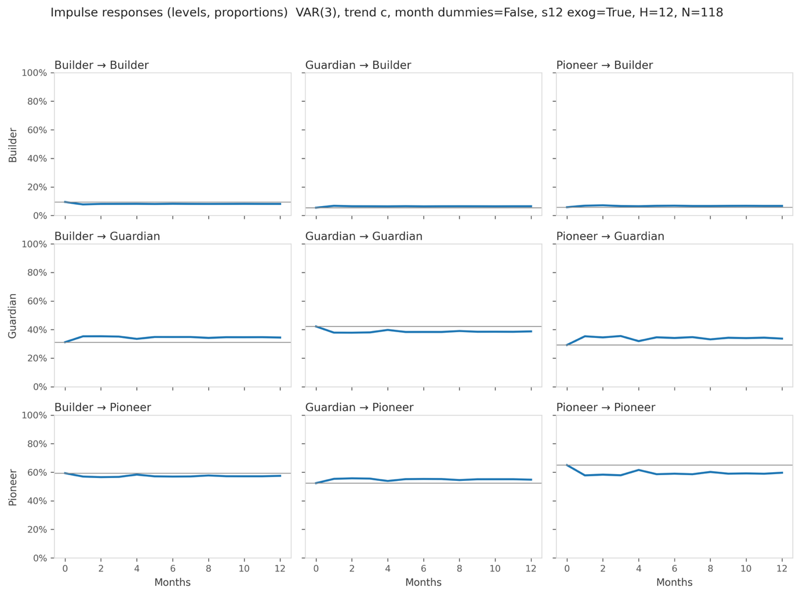

Interpretation (Δ‑Proportions, percentage points)

Peak impulse response effects (Δ-proportions, percentage points)
Shock →  Response ↓ | Pioneer | Builder | Guardian
Pioneer | −7.2 pp  month 1 | −2.8 pp  month 2 | +3.4 pp  month 2
Builder | +1.4 pp  month 2 | −1.7 pp  month 1 | +1.3 pp  month 1
Guardian | +6.3 pp  month 3 | +4.1 pp  month 2 | −4.4 pp  month 2
Note. Generalized impulse responses from VAR(3) on first-differenced ILR coordinates, back-transformed to proportion space at the sample mean composition. Shocks scaled to 0.30 s.d. for cross-panel comparability. Each cell reports the peak absolute effect and the month at which it occurs. Shaded diagonal cells are self-effects (all negative, indicating mean reversion). Off-diagonal cells are cross-archetype effects. Effects typically dampen by months 9–12.

C.8 Forecast Error Variance Decomposition (12 months)

The forecast error variance decomposition (FEVD) quantifies how much of each archetype’s variance at a given horizon is attributable to shocks originating in the Pioneer–rest axis (z1) versus the Builder–Guardian axis (z2). The decomposition reveals a clear structural hierarchy. Pioneer variance is predominantly self-driven, with 88–90% loading on the z1 axis across all horizons. This confirms that speculative discourse follows its own momentum (driven by exogenous events like technological developments; which are out of scope of this analysis) and is only modestly influenced by the Builder–Guardian dynamic. Guardian variance loads 67–69% on the Pioneer–rest axis, indicating that shifts in the legitimation stance are substantially shaped by movements in speculative novelty. This is consistent with the dominant Pioneer→Guardian loop identified in the impulse response analysis. Builder variance loads 65–72% on the Builder–Guardian axis, confirming that mobilization is structurally positioned as a reactive discourse that responds primarily to the tension between novelty and control rather than driving the ecology independently. This pattern is stable across forecast horizons of 1, 6, and 12 months, as shown in the table below.
Approximate variance attribution in proportion space (rows: archetype whose variance is decomposed; columns: ILR shock source) [%]
Horizon (months) | Archetype | z1: Pioneer vs. √(B×G) | z2: Builder vs. Guardian
1 | Builder | 28.2% | 71.8%
 | Guardian | 68.9% | 31.1%
 | Pioneer | 90.3% | 9.7%
6 | Builder | 35.0% | 65.0%
 | Guardian | 67.2% | 32.8%
 | Pioneer | 88.2% | 11.8%
12 | Builder | 33.5% | 66.5%
 | Guardian | 67.1% | 32.9%
 | Pioneer | 88.4% | 11.6%
Note. FEVD computed in proportion space from generalized impulse responses of the main VAR(3) specification (no month dummies, seasonal lag-12 exogenous). Each row sums to 100%. z1 captures the Pioneer–rest axis; z2 captures the Builder–Guardian axis.
In summary, the FEVD confirms the structural interpretation from the impulse response analysis: the discourse ecology is organized around two axes, with Pioneer and Guardian forming the dominant tension and Builder operating as a secondary, reactive stance that bridges the two. The stability of these proportions across horizons indicates that this structural hierarchy is a persistent feature of the ecology rather than a transient pattern.

Robustness and Sensitivity Checks
Specification robustness: The main specification (p=3, no month dummies, seasonal lag-12) was selected by BIC. Alternative specifications confirm the structural patterns: (i) VAR(3) with 11 month dummies (the original specification): all IRF signs are identical, magnitudes differ by less than 0.4 pp, and the FEVD structure is unchanged; (ii) VAR(5) without month dummies (selected by AIC, HQIC, and FPE): IRF signs are preserved, cross-equation coefficients are marginally stronger (L3.z2→z1: p=0.030 vs. p=0.048 in the main specification), and the FEVD patterns are substantively identical. The month dummies were individually insignificant in all specifications and their removal improved the observations-per-parameter ratio from approximately 6 to 13.
Granger causality. Formal Granger causality tests on the two ILR coordinates do not reach statistical significance at conventional levels. In classical econometric forecasting, this would limit claims of strict, unidirectional causality. However, in the context of modeling complex, endogenous IT ecosystems {Adomavicius et al., 2012, #249228}, our objective is not to isolate independent causal mechanisms, but to map the structural rebalancing of a finite attention space. Because our data is compositional (shares summing to 100%), a shock to one archetype mathematically necessitates a redistribution across the others. The theoretical value of our VAR lies in revealing the pattern of that redistribution. We establish the sociological validity of these patterns over mere mechanical artifacts through three features: (a) the cross-archetype responses peak at months 2–3 rather than instantaneously, reflecting the temporal pace of discursive adjustment; (b) the effects are asymmetric (e.g., Pioneer→Guardian operates at a larger magnitude than Guardian→Pioneer); and (c) the structural bridging sequence observed in the VAR perfectly converges with the non-parametric event study in Appendix D, which demonstrates the "Wedge Effect" in raw, untransformed data. Therefore, we interpret the impulse responses as robust, systemic interaction tendencies rather than isolated causal effects.
Residual diagnostics. The system-level Portmanteau test fails to reject the null of white-noise residuals (test statistic=39.87, p=0.302). Jarque-Bera rejects residual normality (p<0.001), likely reflecting heavy-tailed attention distributions during the post-ChatGPT surge. We rely on Monte Carlo confidence bands (2,000 draws) for inference, which are robust to non-normality. The exclusion of surge months (late-2023/early-2024) confirms that IRF patterns persist though peak magnitudes attenuate.
Additional checks. Smoothing windows of 2 or 4 months: IRF signs unchanged, magnitudes vary slightly. Alternative archetype mapping (alternative vision×stance assignments): cross-effects remain positive, self-damping persists. Absolute counts versus article-normalized shares: level differences change, IRF directions stable.
Note: Cross-archetype responses are positive; all three archetypes exhibit negative self-effects. Variance decomposition highlights the dominant Pioneer–Guardian balancing loop, with Builder as a secondary, reactive discourse.

Appendix D: Opposite-direction episodes
and short-run surges in Builder
Question. Do brief surges in Builder attention follow moments when Pioneer and Guardian move in opposite directions: when one is gaining while the other loses it?
Measure. We work with monthly shares of attention (percentage of paragraphs in given month) for Pioneer, Guardian, and Builder (no smoothing). For each month we compute the opposite-direction amplitude: a month qualifies when Pioneer and Guardian move in opposite directions (one up, the other down) and we size the episode by the combined absolute movement that month (how big the divergence was). This gives us a ranked list of “out-of-sync” months.
Event design. We mark events at two thresholds:
- Top 15% of opposite-direction amplitudes (11 episodes), and
- Top 10% (8 episodes).
For each event we trace Builder’s share for the next three months and plot the average change relative to the month before the event (so “0” means no change versus t=−1). We also run a leave-one-event-out jackknife to show how much any single episode drives the average.
Results.
- Top-15% events (N=11): Builder shows a clear, short-run bump that peaks about three months after the shock at roughly +10 percentage points relative to the pre-event month. The jackknife range stays positive (about +8.7 to +13.4 pp), indicating the pattern is not driven by any single episode.
- Top-10% events (N=8): The bump is smaller but still positive, peaking near +3–4 pp by month 3. Jackknife peaks remain positive (about +3.3 to +12.4 pp), though the range is wider given fewer events.

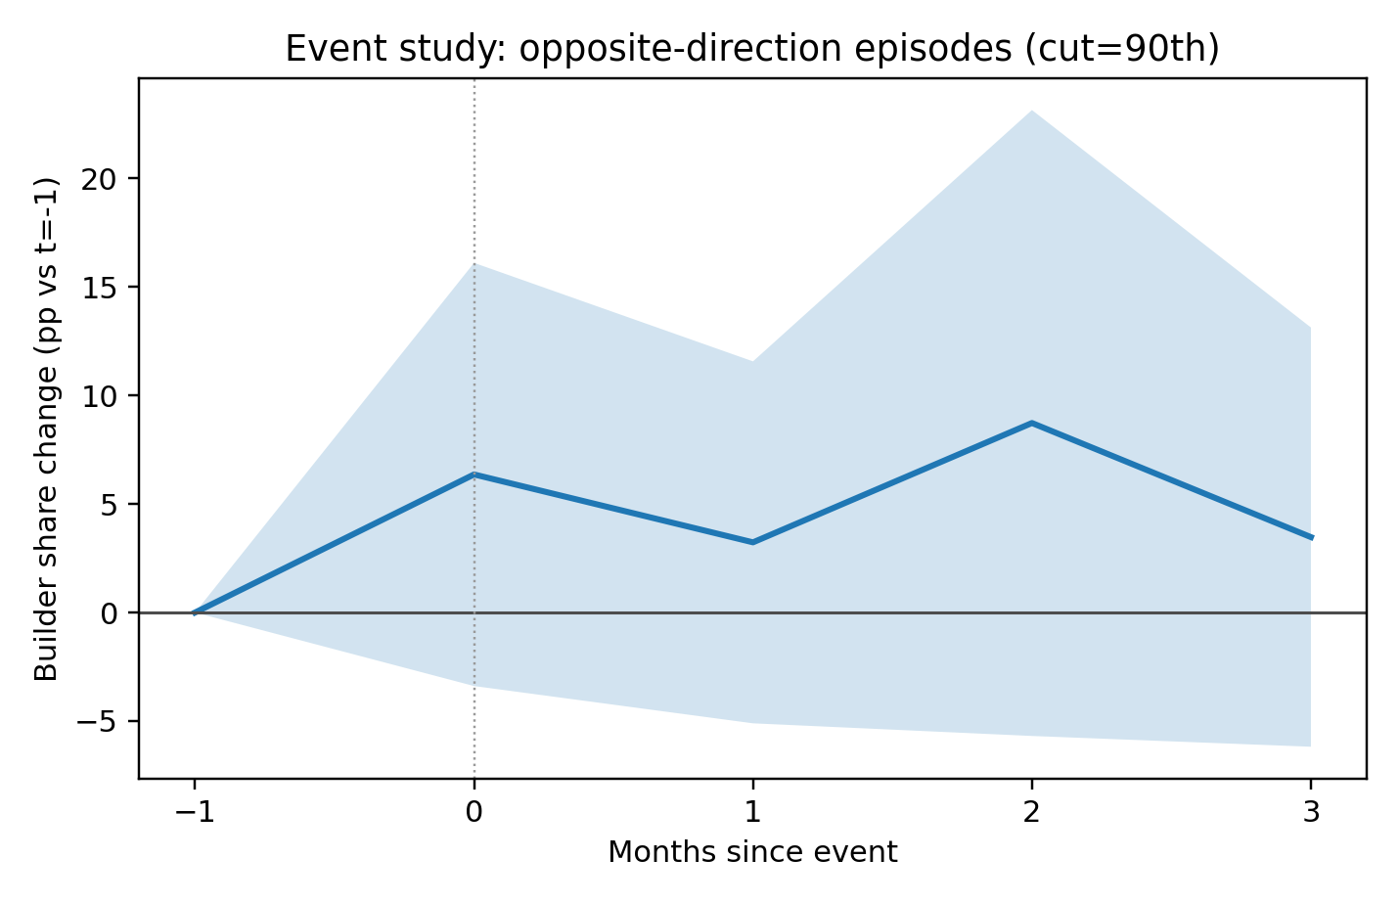

Event study: opposite-direction episodes (cut=90th percentile). Line shows the average change in Builder’s monthly share relative to the pre-event month (t=–1). Shaded band is the 95% CI across events; vertical dotted line marks the event month (t=0). Builder rises modestly within 1–3 months following strong opposite-direction movements in Pioneer vs. Guardian

Interpretation: These event paths match the theoretical expectation: when novelty-seeking (Pioneer) and control-seeking (Guardian) discourse pull apart, attention temporarily shifts into Builder mode as actors try to translate and stabilize what’s happening. The effect is short-run (within one to three months) and more visible when the divergence is sizable.

Notes and limitations: These are soft-signal results from discourse shares. Magnitudes should be read as indicative, not structural effects; the main evidence is the sign and timing. Higher thresholds give cleaner signals but fewer events; lower thresholds increase N and dilute the bump. All analyses use shares (not counts), no smoothing, and the same monthly sample used elsewhere in the paper.

Appendix E: Index of Cited Practitioner Articles

Transparency Note on Practitioner Sources: Because the practitioner discourse comprising our corpus is frequently hosted behind proprietary paywalls (e.g., Harvard Business Review and MIT Sloan Management Review), standard web-based search engines may fail to retrieve specific paragraph-level instances. To ensure the auditability and replicability of our qualitative grounding,
Appendix E provides a complete index of cited articles alongside their corresponding database Accession Numbers (AN) afor direct retrieval via the EBSCO Business Source Ultimate archive.

Ref ID | Year | Outlet | Article Title | Authors
[P-01] | 2014 | HBR | Artificial Intelligence Can't Replace Hard-Earned Knowledge - Yet | Swap & Leonard
[P-02] | 2015 | HBR | Research: Technology Is Only Making Social Skills More Important | Torres, N.
[P-03] | 2017 | HBR | AI May Soon Replace Even the Most Elite Consultants | Libert & Beck
[P-04] | 2022 | SMR | What Humans Lose When We Let AI Decide | Moser, et al.
[P-05] | 2022 | HBR | Marketing in the Age of Alexa | Dawar, N.
[P-06] | 2023 | HBR | AI with a Human Face | Seymour, et al.
[P-08] | 2019 | SMR | The Only Way Manufacturers Can Survive | Govindarajan, V, et al.
[P-09] | 2018 | HBR | Why We Need to Audit Algorithms | Guszcza, et al.
[P-10] | 2022 | HBR | Where Automated Job Interviews Fall Short | Zahira, Jaser, et al.
[P-12] | 2020 | HBR | Competing in the Age of AI | Iansiti & Lakhani
[P-14] | 2015 | HBR | Artificial Intelligence Is Almost Ready for Business | Power, B.
[P-15] | 2016 | HBR | How to Make Your Company Machine Learning Ready | Hodson, J.
[P-16] | 2017 | HBR | AI Can Be a Troublesome Teammate | Gray, K.
[P-17] | 2022 | HBR | Find the Right Pace for Your AI Rollout | Karp & Peterson
[P-18] | 2024 | HBR | How Companies Can Build Trustworthy AI Assistants | Baxter & Schlesinger
[P-19] | 2016 | HBR | Can We Teach Algorithms Right From Wrong? | Satell, G.

